Need for Skilled Nursing Beds in Hamilton
Exhibits of Leslie Hendrickson, Ph.D.
December 18, 2008 Hamilton Township, New Jersey,
Zoning Board of Adjustment

Summary
CareOne at Hamilton has made a request for additional skilled nursing beds. Skilled nursing beds are used for two purposes: subacute care and long-term living. Regarding subacute care, more persons are coming out of hospitals needing subacute care. There is a nationwide trend in the growing percentage of persons in nursing homes that use skilled post-acute care services

Regarding long-term living, the number of nursing homes, number of nursing home beds and number of nursing home residents has been flat for at least a decade. However, the population of persons over the age of 85 will rise substantially this decade and in 2015 the number of persons over the age of 75 will begin a significant increase. The majority of persons receiving services at Hamilton will come from within five miles of the Care Center.

SUB-ACUTE CARE
More persons are coming out of hospitals needed skilled nursing home rehabilitation care
The ready availability of skilled medical and nursing rehabilitation services is essential for the health and safety of the general population. The need for additional skilled nursing home beds has been steadily growing as the population has aged. The most frequent reason persons go to nursing homes is to receive post-acute care after an acute care hospital stay. These are mostly Medicare-eligible persons age 75 and older who have had hip or knee replacements, cardiac arrests, strokes, and significant surgery, and who need continuous skilled care beyond the number of inpatient hospital days they are allotted. The post-acute rehabilitation services that they receive are authorized and paid for by Medicare and include ongoing medical monitoring such as wound dressing and medication management, plus physical, occupational, and speech and hearing therapy. These persons come to nursing home with suction pumps, oxygen concentrators, wheelchairs, new prosthetic devices, tubes, and other medical equipment. Fifteen years ago these persons would have been cared for in the hospital. The kind of care they need is not provided in Senior Centers, by outpatient physical therapy agencies, or at local physician offices.

Federal Medicare statistics in Table 1 below show that more persons are being discharged from hospitals. The number has increased from 10.5 million in 1985 to 12.5 million in 2006. Figure 1 also shows that more persons are using services and the length of time persons spend in hospitals has decreased from 8.7 days per stay in 1985 to 5.6 days per stay in 2006.

Figure 1 Shows Hospital Discharges, Days of Care and Average Length of Stay
1985-2006
Medicare Short Stay Hospital Utilization
Selected Fiscal years
 | 1985 | 1990 | 1999 | 2000 | 2004 | 2005 | 2006
Discharges
Total in Millions |  | 10.5 | 11.7 | 11.8 | 13.0 | 13.0 | 12.5
Rate per 1,000 Enrollees | 347 | 313 | 310 | 303 | 316 | 308 | 291
Days of Care
Total in Millions | 92 | 94 | 71 | 71 | 75 | 75 | 71
Rate per 1,000 Enrollees | 3016 | 2805 | 1897 | 1825 | 1834 | 1771 | 1655
Average Length of Stay
All Short Stay | 8.7 | 9.0 | 6.1 | 6.0 | 5.8 | 5.7 | 5.6
Excluded Units | 18.8 | 19.5 | 12.6 | 12.3 | 11.5 | 11.6 | 11.7
Total Charges per Day | $ 597 | $ 1,060 | $ 2,496 | $ 2,720 | $4,458 | $ 4,882 | $5,344
Source: CMS Medicaid 2007 Statistics, Baltimore, Md.

There is a nationwide trend in the growing percentage of persons in nursing homes that use skilled post-acute care services.

The next Figure shows the percent of nursing home residents both in the United States and in New Jersey that use sub-acute care rehabilitation services. These services are prescribed by a doctor and are medically necessary. As the table shows the national percentage of persons who enter the home to benefit from Medicare-paid rehabilitation has been steadily increasing and the New Jersey percentage has grown from 11% to 17% from 2001 to 2008.

Figure 2 Percent of Nursing Home Residents Using Short-term Medicare
Nursing Home Rehabilitation Services 2001-2008
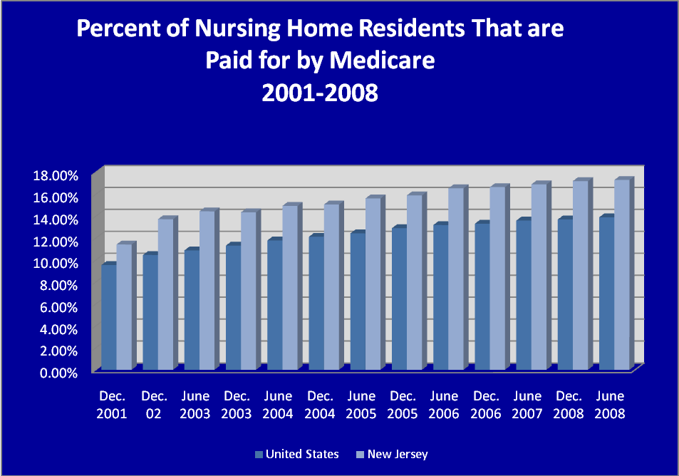
Data Source: Centers for Medicare and Medicaid Services, On-line Survey Certification and Reporting System (OSCAR)

Approximately 80-85% of the persons who currently come to CareOne in Hamilton for subacute services come from RWJ, St. Francis, and the two Capital Hospitals at Fuld and Mercer. These four hospitals collectively discharge about 49,000 persons a year and these numbers are going to grow as the percentage of older persons in the population increases.

LONG-TERM LIVING
A second reason persons use nursing homes is for long-term living. The next figure shows data for this decade about New Jersey nursing homes. Generally the data show how flat the growth in the number of homes, the number of beds, and the number of persons using nursing homes has been.
Figure 3 Nursing Home Use in New Jersey 2003-2008
 | June-03 | June-04 | June-05 | June-06 | June-07 | June-08
Total Patients | 44,811 | 44,569 | 44,720 | 45,368 | 45,951 | 45,824
Medicare % | 14.44% | 14.94% | 15.62% | 16.54% | 16.90% | 17.30%
Medicaid % | 64.40% | 64.93% | 65.05% | 64.09% | 63.00% | 62.60%
Other Payer % | 21.16% | 20.13% | 19.34% | 19.37% | 20.10% | 20.10%
Number of Nursing Homes | 359 | 357 | 360 | 361 | 361 | 361
Number of Beds in Homes | 51,148 | 50,670 | 50,906 | 51,478 | 51,088 | 51,040
State Home Occupancy Rate | 87.61% | 87.96% | 87.85% | 88.10% | 88.50% | 89.80%
Average size of Home | 142 | 142 | 141 | 143 | 142 | 141
Number of Persons over age 75 |  | 574,074 | 581,773 | 587,831 | 592,091 | 595,063

So why have these numbers been flat? There are two major reasons. The first is the state’s certificate of need policy. The state of New Jersey has had a certification of need process that goes back to the 1971 Health Care Facilities Planning Act, P.L. 1971 c. 136. The state’s certificate of need regulation restricts the number of nursing homes and nursing home beds that can be built. The restriction is effective. In December 2001, New Jersey had 50,769 beds and in June 2008 New Jersey had 51,040, a gain of less than one half of one percent. The second reason is both state and federal policies that encourage the use of home and community-based services and discourage nursing home use.

However the demand for nursing home services continues to grow as the population becomes older. The average nursing home occupancy rate in Mercer County, excluding the county home, is 92%. In 2000, there were approximately 135,999 persons over the age of 85 in New Jersey whereas in 2010 the number of persons 85 years of age and older is projected to be 198,835, an increase of 46 per cent. The U.S. Census population pyramids in Appendix A show these percentage increases in the age 85 and older populations.

The following table shows the growth in the number of persons over the age of 75 in New Jersey projected out to 2030. While the growth is relatively flat between 2004 and 2014 it begins a significant increase in about 2015, adding almost 300,000 more persons over the age of 85 in 15 years.
Figure 4 U.S. Census Projections for Growth in New Jersey
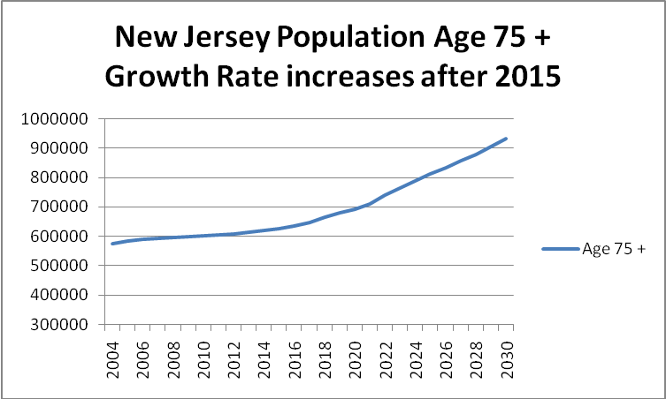
Data Source: File 3. Interim State Projections of Population by Single Year of Age: July 1, 2004 to 2030
Where will persons come from to receive services at Hamilton?
A study of travel distances from hospitals to nursing homes in New Jersey found that more than 95% of persons traveled less than 10 miles from a hospital to a nursing home. The next Figure, Table 3, shows national data on relocation distances for assisted living and dementia care units. These are common long-term care programs and upwards of 50% of the persons move less ten miles to enter these medical/residential programs.

Figure 5 Shows Resident Relocation Distances for Residential Health
Care Programs
Distance from Previous Living Location | Free standing Assisted Living | Free standing Dementia Care Units
Less Than 5 miles | 35.90% | 19.60%
5-10 miles | 27.80% | 33.70%
11-25 miles | 16.10% | 32.60%
26-50 miles | 7.30% | 9.80%
Greater than 50 miles | 12.80% | 4.30%
Total | 99.90% | 100.00%
Source: American Association of Homes and Services for the Aging 2006 Assisted
Living, Table 6.7.

The attached map in Appendix A shows that 62% of current residents at Hamilton come from within 5 miles. The Hamilton specific data shows that more residents live closer to the Care Center than would be expected from the national data in Figure 5.
When a person leaves a hospital and needs continued medical observation and skilled rehabilitation the families and persons who need this essential care wish to travel locally to receive it. A shorter distance to the nursing home can result in more visits, longer stays, and better coordination of care.
Figure 6 below shows how many persons aged 65 and older are within 0-5 miles and 0-10 miles of Hamilton. In other words, if you obtained a map and drew a circle that was five miles around Hamilton about 27,748 persons over the age of 65 would live in that circle. About 65,000 would live in a ten-mile circle around Hamilton.

Figure 6 Shows Numbers of Persons 65 Years of Age and Older
Who live Close to Hamilton
Miles from Hamilton | In 2012 Persons aged 65 and older
Within 0-5 miles | 27,748
Within 0-10 miles | 64,954
Source: Claritas Company. www.claritas.com
If sufficient sub acute and long-term living services are not accessible within reasonable distances from Hamilton, then it is this group of 65,000 persons that will be impacted. If course not all 65,000 will be, but there will be persons from this group who will experience more stress, more difficulty receiving family support, less time spent visiting, and increased travel time and cost
The need for these beds is further highlighted by the continuing hospital closures that New Jersey is experiencing and will continue to experience.
Summary
A modest expansion of skilled nursing beds is necessary to meet the public need for increased skilled medical care services that can only be provided in a medical facility such as Hamilton. The beds support medically necessary services as prescribed by a doctor. The demographic and hospital utilization data show that increased numbers of persons are using post acute services now and that these numbers will substantially increase in New Jersey in the coming years. Demographic projections show an almost 50% increase in the population of person over the age of 75 will take place in New Jersey between 2015 and 2030. In New Jersey, about 63% of the nursing home population is paid for by Medicaid and some proportion of the users of the skilled nursing services will be so impoverished that they receive medical assistance.

Appendix A Year 2000 and Year 2010 Population Pyramids for New Jersey from U.S. Census
and Map of Hamilton Area showing where existing residents come from
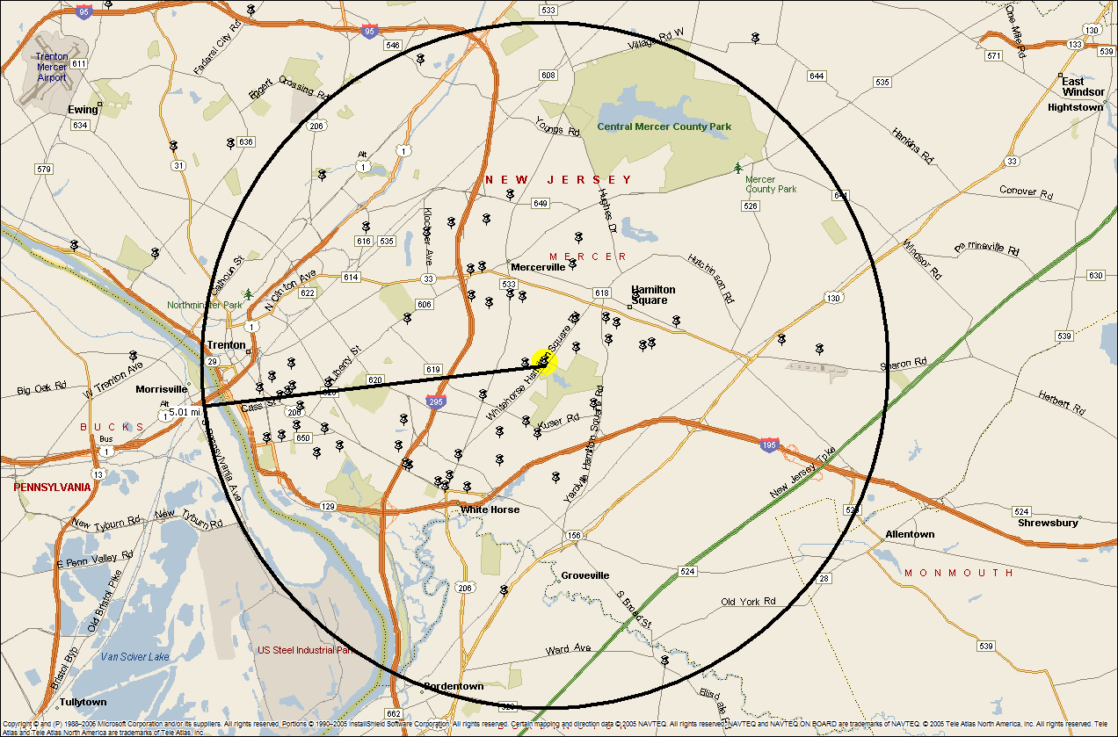

In 2006 about 7.4% of all persons experienced a stay in a nursing home Centers for Medicaid and Medicare Services, (2007) Nursing Home Data Compendium, Baltimore, MD. Table 1.6. Percentage of State Residents With At Least One Nursing Home Stay: United States, 2006
Data obtained from the New Jersey Department of Health and Senior Services.
Center for Medicare and Medicaid Services OSCAR data. Data for June 2007 was retrieved on 3-3-08 from http://www.ahcancal.org/research_data/oscar_data/Pages/default.aspx
Calculation of the author from Medicare OSCAR data. For some reason the county operated home is only showing an occupancy of 62%.
See U. S. Census download pages for 2000 and 2010 New Jersey data. The bottom right hand part of the pyramid shows the percentage increase in older population cohorts from 2000 to 2010. http://www.census.gov/population/www/projections/statepyramid.html
Retrieved on 12-3-08 from http://www.census.gov/population/www/projections/projectionsagesex.html
Study done by the author.
The map in Appendix was prepared by the author based on information supplied by the Care Center.
For an example of the continuing concern of the New Jersey public over the frequent closure of local hospitals see the recent study by the Center for State Health Policy at Rutgers University. Retrieved on 3-3-08 from http://www.cshp.rutgers.edu/Downloads/NJHOP/PUB%20OPINION%20WEB.pdf

