Testimony of Leslie Hendrickson, Ph.D.
March 17, 2011
Teaneck Township Board of Adjustment

Documents and Tables about Use of Nursing Homes

Use of Nursing Homes by Medicare Beneficiaries
Data Source: Cotterill, P., & Gage, B. (2002, Winter). Overview: Medicare post-acute care since the balanced budget act of 1997. Health Care Financing Review 24 (2), 1-6. Retrieved on March 13, 2011, from: https://www.cms.gov/HealthCareFinancingReview/downloads/02Winterpg1.pdf
Alliance for Quality Nursing Home Care (2009, September), Trends in Post-Acute and Long-Term Care, Care Connect. Retrieved on 3-14-11 from http://www.aqnhc.org/www/file/AQNHC_Care_Context_914%20Updated.pdf?phpMyAdmin=HzHnhISAGxbugH-niVxYkWiXQq0
“The nursing facility PPS, implemented in 1998, allowed for higher payments for more clinically complex patients. Nursing facility complexity increased and length of stay decreased. CMS also tightened patient criteria for certain post-acute care providers, for example, inpatient rehabilitation facilities in 2004, resulting in nursing facilities caring for an even greater share of certain rehabilitation patients.” The allowing for higher payments was definitely true for New Jersey in the author’s first-hand experience with New Jersey Medicare rates before and after 1998.
Data Source: Cotterill, P., & Gage, B. (2002, Winter). Overview: Medicare post-acute care since the balanced budget act of 1997. Health Care Financing Review 24 (2), 1-6. Retrieved on March 13, 2011, from: https://www.cms.gov/HealthCareFinancingReview/downloads/02Winterpg1.pdf
Figure 3 Shows Total Medicare Covered Nursing Facility Days, 1995-2009
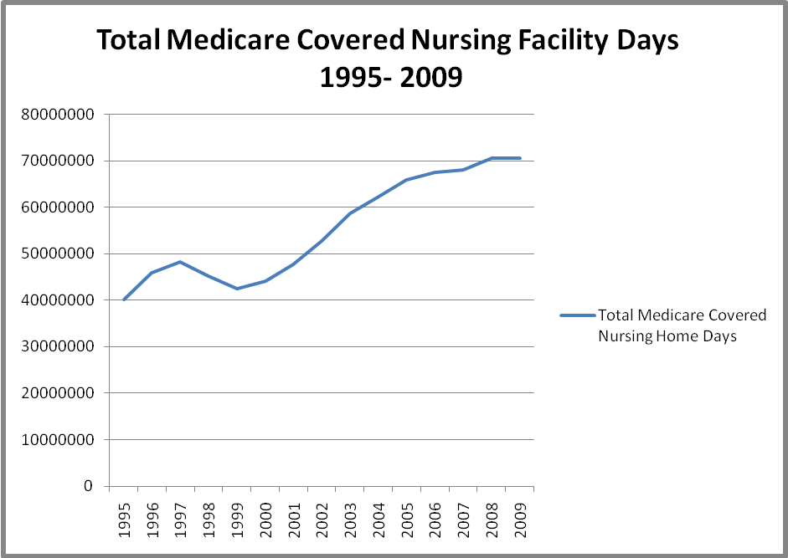
The data above are taken from the Data Compendium series published by the Centers for Medicare and Medicaid Services. For example, see retrieved on 3-16-11 http://www.cms.gov/DataCompendium/20_2002_Data_Compendium.asp#TopOfPage and https://www.cms.gov/MedicareMedicaidStatSupp/16_2003.asp
Table Showing Change in the Number of Persons in New Jersey Nursing Homes who are Paid for by Medicare, 2001-2009.
 | Dec-01 | Dec-02 | Dec-03 | Dec-04 | Dec-05 | Dec-06 | Dec-07 | Dec-08 | Jun-09
NJ | Number Medicare | Number Medicare | Number Medicare | Number Medicare | Number Medicare | Number Medicare | Number Medicare | Number Medicare | Number Medicare | % Change
Point in Time | 5,121 | 6,121 | 6,369 | 6,730 | 7,135 | 7,604 | 7,835 | 7,857 | 8,228 | 61%
Yearly Estimate | 74,764 | 89,367 | 92,989 | 98,252 | 104,177 | 111,012 | 114,388 | 114,709 | 120,128 | 61%
Data Source: Research and Statistics Unit, American Health Care Association Its web site is http://www.ahcancal.org/research_data/Pages/default.aspx
Converted to yearly estimate by Hendrickson Development assuming average length of stay of 25 days.

The Table above shows that at the end of 2001 Medicare paid for about 75,000 persons annually in New Jersey nursing homes. By 2009, there was a 61% increase to a 120,000.

A Look at Factors affecting the increased use of Nursing Homes
Angelelli, J., et al. (2002), Access To Postacute Nursing Home Care Before And After The BBA, Health Affairs, 21, no.5 (2002):254-264.
This study examined the Ohio Medicare nursing home data for 1996 to 1999. It found the BBA did not reduce admissions to nursing homes; rather the homes persons went to changed. “We found that 15 percent of hospital-based facilities operating in 1998 had closed by mid-2001 (thirteen of eighty-three)” See, retrieved on 3-17-11 http://content.healthaffairs.org/content/21/5/254.full.pdf+html
Medicare Payment Advisory Commission, (2002, March), Medicare Payment Policy: Report to Congress, Washington, D.C. p.87
This report to congress showed that 20% of all hospital based nursing homes closed as a result of BBA 1997, almost 400 nationally. See, retrieved on 3-17-11 http://www.medpac.gov/documents/Mar02_Entire%20report.pdf
McCall, N. Korb, J., Petersons, A., & Moore, S., (Winter 2002). Constraining Medicare home health reimbursement: what are the outcomes? Health Care Financing Review, 24 (2), 57-76.

The Balanced Budget Act of 1997 contained major curbs on the reimbursement of home health agencies and resulted in declines in the number of home health agencies and the numbers of patients that they treated.
This study found statistically significant differences in the rates of nursing home admissions prior to the implementation of the Balanced Budget Act and afterward in 1999 by persons who had been receiving home health services. See Table 3
Retrieved on 3-13 from http://www.rwjf.org/files/research/HCFR-Winterpg57-Constraining.pdf
CRS Report for Congress, (2006, January), Medicare Payment Issues Affecting Inpatient Rehabilitation Facilities (IRFs), Congressional Research Office, Washington, D.C. Retrieved on 3-11-11 from http://www.policyarchive.org/handle/10207/bitstreams/2254.pdf

In 2002, Medicare introduced broad reimbursement changes to post-acute providers such as inpatient rehabilitation facilities, (IRFs). These changes were adopted in 2004. The changing reimbursement patterns are believed to have resulted in a greater use of skilled nursing facilities for rehabilitation. This research paper also makes references to the impact of changing Medicare hospital reimbursement on the rate of hospital discharges. Also in 2002, Medicare implemented a per discharge PPS for long-term hospitals using modified diagnosis-related groups (DRGs) and this had a similar impact of pushing utilization out of hospitals and into nursing homes.

See also, retrieved on 3-11-11 from, http://www.aqnhc.org/www/file/AQNHC_Care_Context_914%20Updated.pdf?phpMyAdmin=HzHnhISAGxbugH-niVxYkWiXQq0 for a direct comment about the impact of the 2002 -2004 rules on nursing homes.

Data on Acuity of Nursing Home Residents during 2003-2007
Percentage of Nursing Home Residents
Number of Activity of Daily Living (ADL) Impairments
 | 0 | 1 | 2 | 3 | 4 | 5
2003 | 34.0% | 9.0% | 8.4% | 9.6% | 20.2% | 18.8%
2004 | 33.3% | 8.8% | 8.2% | 9.4% | 21.8% | 18.6%
2005 | 32.3% | 8.6% | 7.9% | 9.2% | 23.5% | 18.5%
2006 | 30.3% | 8.3% | 7.6% | 9.0% | 26.4% | 18.5%
2007 | 28.9% | 8.1% | 7.2% | 8.8% | 28.6% | 18.4%
Data Source: Hendrickson Development, data from CMS Nursing Home
Compendium, 2007

Gage, B (2009, February) Examining Post Acute Care Relationships in an Integrated

Hospital System: Final Report, A report prepared for the Assistant Secretary for Planning and Evaluation (ASPE), U.S. Department of Health and Human Services, Washington, DC.

http://aspe.hhs.gov/health/reports/09/pacihs/index.shtml

Other Factors Affecting Occupancy Rates of Long-Term Residents of Nursing Homes

Alecxih, L., (November, 2006), Nursing Home Use by "Oldest Old" Sharply Declines, Presentation to the National Press Club, Washington, D.C. Retrieved on 3-11-11 from http://www.globalaging.org/elderrights/us/2006/oldestold.pdf

This presentation outlines reasons for the decreasing use of nursing homes by older populations. The population of classic long-term residents has markedly declined. These reasons include:
- a decline in age adjusted disability rates i.e., older persons are healthier than they used to be;
- increased post-acute care is replacing the long-term stayers;
- availability of alternatives such as assistant living;
- availability of long-term care insurance; and
- state efforts to reduce Medicaid populations.

“Money Follows the Person”, one consequence of the 1999 Olmstead decision, is a significant Federal Medicaid effort to reduce the size of populations in nursing homes, state mental health hospitals and facilities serving persons with intellectual and developmental disabilities. There is a large amount of information about this program. For example, the Federal Medicaid agency has recently awarded $621 million to 13 states for a five-year effort to help persons leave these facilities. These 13 states join 30 others that have previously won awards. Some 43 states are now involved in this program wherein the Federal Medicaid agency pays 100% of the administrative cost of operating the programs. The news announcement of the latest grantees is found at http://www.hhs.gov/news/press/2011pres/02/20110222b.html

Jencks, S., Williams, M. & Coleman, E. (2009, April 2), Rehospitalizations among Patients in the Medicare Fee-for-Service Program, New England Journal of Medicine, 2009; 360:1418-1428

Almost one fifth (19.6%) of the 11,855,702 Medicare beneficiaries who had been discharged from a hospital in 2003-2004 were rehospitalized within 30 days, and 34.0% were rehospitalized within 90 days; Article has a good bibliography of other literature on rehospitalization

Les Hendrickson, Ph.D.
Hendrickson Development
leslie.c.hendrickson@gmail.com
http://www.hendricksondevelopment.biz
609-213-0685 (cell)
609-443-1809 (fax)

