TABLE OF CONTENTS

- Executive Summary 3

- Background and Understanding 5
  - Context of Study
  - Project Goals

- Stakeholder Input 9
  - Description of Methodology
  - Overview of Strengths and Weaknesses Analysis

- Alternative Rate Setting Methodologies 14
  - Rate Setting Definitions and Methodologies
  - Alternative Rate Methodologies in Ohio
  - Peer State Analysis

- PASSPORT Waiver Evaluation 53
  - Description of Waiver Program Administration and Rate Setting
  - Strengths & Weaknesses Analysis
  - Rate Setting Recommendations

- Assisted Living Waiver Evaluation 98
  - Description of Waiver Program Administration and Rate Setting
  - Strengths & Weaknesses Analysis
  - Rate Setting Recommendations

Acknowledgements

Appendix A: Stakeholder Input (Not Related to Rate Setting)

I. Executive Summary

The Ohio Department of Aging (ODA) contracted with Public Consulting Group, Inc. (PCG) in June of 2008 for the purpose of evaluating Ohio’s current provider rate setting methodologies for PASSPORT and Assisted Living Waiver services and to provide recommendations for alternative rate setting methodologies. ODA entered into this contract in an effort to improve accountability, create more rate transparency, and improve outcomes related to rate setting. These factors provided the catalyst for Ohio’s request of PCG to conduct a system analysis and recommend possible solutions for change.

PCG has prepared a comprehensive review of the PASSPORT and Assisted Living Waiver reimbursement systems. As part of the review, PCG analyzed Waiver documents, read CMS audit reports, completed stakeholder interviews, reviewed relevant ODA reports, and analyzed PIMS data in an effort to document the strengths and weaknesses of the system. PCG has also conducted a comprehensive alternative rate methodology review in an effort to find comparable peers and best practices within other Ohio programs and peer state programs.

The culmination of PCG’s detailed analysis has resulted in list of rate recommendations below. The recommendations made by PCG are intended to promote efficiency, economy, quality of care, and access of Waiver services for Ohioans eligible for the PASSPORT and Assisted Living Waiver. PCG notes that recommendations provided in this report are contingent on future ODA budget limitations and restrictions. Moreover, these recommendations will require increased administrative investment by ODA and should be vetted before implementation. PCG provides these recommendations in the belief that they are the best practices that Ohio can implement given the current characteristics of its PASSPORT and Assisted Living program. Detail for each recommendation can be found in the report that follows.
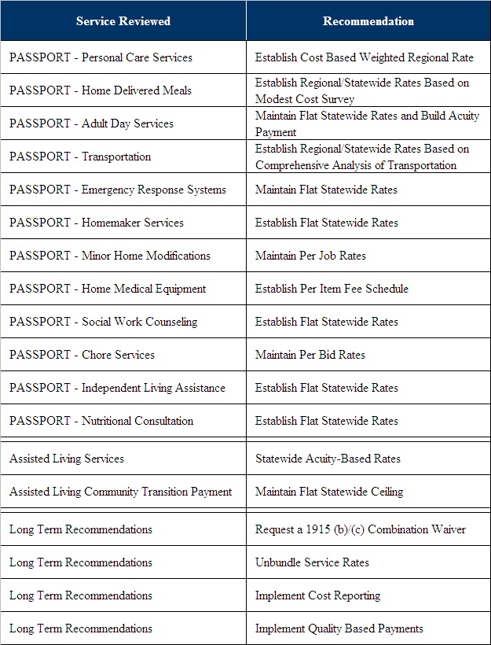

II. Background and Understanding

A. Context of Study

In April of 2008, the Ohio Department of Aging (ODA) issued a Request for Proposals (RFP) titled Evaluation of Ohio’s Medicaid Rate Setting Methodology for Preadmission Screening System Providing Options and Resources Today (PASSPORT) and Assisted Living Waiver Programs. As stated in the RFP, the scope of work for this project was to:

- Determine the strengths and weaknesses of Ohio’s current rate setting methodology for the PASSPORT Waiver program.
- Determine if the current PASSPORT system is efficient, cost effective, and allows for the purchase of the service at the lowest rate that will insure consumer access to these services.
- Provide a complete description of alternative generally accepted methodologies for setting Medicaid home and community based service (HCBS) rates, the pros and cons of each methodology, and a recommendation for a methodology which should include all PASSPORT “per unit rate” services and “flat rate” services, including as one of the methodologies a regional average rate model.
- Determine the strengths and weaknesses of the current rate setting methodology for the Assisted Living Waiver.
- Determine if the current Assisted Living system is efficient, cost effective, allows for the purchase of the service at the lowest rate possible, insures consumer access to services and provides a fair reimbursement to the provider.
- Provide a complete description of alternative generally accepted methodologies for setting rates for Assisted Living Waiver programs, the pros and cons of each methodology, and a recommendation for a methodology for decentralizing rate setting at the state level, including as one of the methodologies a regional average rate model.

Overall, ODA developed this RFP in order to receive an objective review of their Waiver programs. Each program represents large amounts of state and federal funds. The total budget for PASSPORT in State Fiscal Year 2008 was almost $310.3 million and for Assisted Living was almost $30 million. The recommendations developed through this project aim to provide valuable insights into feasible strategies that ODA can implement to ensure that a high level of quality continues to be provided in a sustainable, cost effective manner.

CMS Comments on Ohio Waiver Programs
ODA is also addressing concerns that the Centers for Medicare and Medicaid Services (CMS) have expressed in regards to their Waiver programs. CMS finalized a Financial Management Review Report on Ohio’s 1915(c) PASSPORT Waiver in April 2003. The purpose of the review was to determine if the State had designed and implemented an adequate system for assuring financial accountability of the PASSPORT HCBS Waiver program. The reviewers sought to examine the rate setting, billing, and claim payment system for the PASSPORT program. The reviewers also focused on how financial records are maintained by the Ohio Department of Job and Family Services (ODJFS), ODA, the PASSPORT Administrative Agencies (PAAs), and the service providers, the nature and frequency of review and audit, and overall financial management of the Waiver.

Issues Addressed
In its report, CMS identified issues with the variation in high and low rates for the same service across the state as well as the variability of average rates by service across the regions. CMS suggested that ODA should consider centralizing the PASSPORT rate setting function at the State level to enhance the consistency and predictability of unit payment rates. CMS further suggested that incorporating peer group techniques (for example, urban and rural peer groups or peer groups based on wage or cost levels) into rate setting methods and that maximums should also be considered, thereby that saying peer grouping would assure relevant and reasonable levels and maximums.

ODA disagreed with this recommendation stating that its current methods allow for competition amongst providers, which ensures the lowest rate possible for the consumer. CMS responded that the variation in rate data suggests that local entities may not always be effective in obtaining good value comparable to other regions. This could potentially impact the availability of willing providers and quality of care. CMS recommended incorporating peer grouping into a centralized rate setting process that would continue to recognize variation in regional market conditions, such as cost of living, wage and price levels, and labor conditions.

Most recently, in a report dated January 11, 2008, CMS reviewed the PASSPORT Waiver to provide recommendations to rate setting functions prior to the renewal process. CMS requested that ODA have a “uniform rate setting methodology for all PASSPORT Waiver services allowing for regional variation based upon tangible indices such as demographic variables.” ODA responded by stating that the state plans to review the methodologies and to propose recommendations that best reflect the Ohio environment. The product would be a methodology that can be considered in the next biennial budget for State Fiscal Year 2010-2011. CMS accepted this response, but requested that at the time of renewal the State should provide evidence that a revised rate methodology is being developed. CMS would like to review the new statewide rate methodology along with an implementation plan. This report can assist ODA in the development of CMS-approved rate methodologies.

B. Project Goals

The workplan developed by PCG in response to the RFP aimed to meet the goals of the prescribed scope of work. As stated previously, the main tasks of this project included:

- Determining strengths and weaknesses of the current PASSPORT rate setting methodology;
- Determining strengths and weaknesses of the current Assisted Living rate setting methodology;
- Recommending alternative methodologies for setting PASSPORT rates;
- Recommending alternative methodologies for setting Assisted Living rates; and
- Developing a draft and final report.

To meet the intent of the RFP and complete its associated tasks, PCG reviewed PASSPORT and Assisted Living Waiver documentation and rate setting methodologies. PCG requested information from ODA on the following: PASSPORT per rate services, PASSPORT per bid services, Assisted Living rates by tier, PASSPORT and Assisted Living regulations, regional rate averages, and provider information. Below is a summary list of all data items that were requested. PCG received all requested data.

Table 1: PCG Data Request
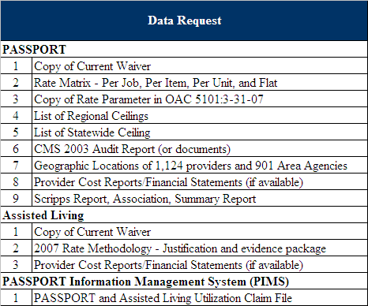

PCG was provided data from the PASSPORT and Assisted Living Utilization claim file. This file contained the following data items:

- Service Code
- Provider ID
- Provider Location ID
- County
- PAA Region
- Units of Service Provided
- Total Expenditures
- Unique Consumers Served

These data items allowed PCG to complete analyses of total expenditures, total units provided, and unique consumers served at a statewide, PAA region, and county level.
The presence of the total expenditures and total units of service allowed PCG to determine the rate of payment negotiated and paid to each provider. These payment rates could be compared with other sources of data requested such as the rate matrix and statewide ceiling spreadsheet. PCG was able to review actual payment rates and compare them to average payment rates, determine the variability of payment rates among counties and regions, and the level of services provided at each rate.

PCG also reviewed documentation related to operation of the Waiver programs, including the current Waiver, and documentation of program reviews by CMS, ODJFS, and Scripps. The information and details included in these reviews is discussed in the report.

After completing these reviews, PCG met with key stakeholders in this process to ask questions and gain more information regarding the program. The steps of research and communication helped PCG determine the strengths and weaknesses of the PASSPORT and Assisted Living Waiver programs. In addition, PCG also used research from other state programs to inform the strengths and weaknesses of the Waiver programs and potential program recommendations. Understanding how other states may set their rates can inform the Ohio process. PCG evaluated the pros and cons of each alternative methodology and has compiled its research findings and recommendations in the report contained herein.

III. Stakeholder Input

A. Description of Methodology

Stakeholder input played an important role in this engagement. It was recognized from the project’s inception that a concerted effort needed to be made to get a variety of stakeholders involved. Participants played a significant role in providing a historical and operation overview of the PASSPORT and Assisted Living Waiver programs, in identifying the strengths and weaknesses of the programs, in evaluating the effectiveness of the PASSPORT and Assisted Living Waiver programs, and in assessing alternative rate setting methodologies. At the same time, stakeholder sessions played an educational role in exposing people to new ways of doing things and in giving people an opportunity to participate in process of designing new approaches. It is the dual nature of stakeholder involvement that made this effort particularly valuable.

PCG gathered stakeholder input through two approaches: individual interviews and focus group sessions. These approaches were designed to gather in-depth information from participants, to ensure that all stakeholder groups were provided the opportunity to participate, and to obtain input from people from different geographic regions of Ohio.

At the onset of the study, a series of individual interviews were conducted. These interviews were important in developing a basic understanding of history and operations of the PASSPORT and Assisted Living Waiver programs, in identifying the sources and availability of data to be analyzed, and to uncover the various issues and concerns. PCG worked with ODA in identifying the list of people to interview. While most of the interviews were done in person, there were some individuals with whom phone interviews were conducted.

Representatives from the following organizations were interviewed:

- ODA – Community Long-Term Care Division
- ODA – Executive Division
- ODA – Elder Rights Division
- ODA – Fiscal Division
- ODA – Information Systems Division
- ODA – Older Americans Act Programs Division
- ODJFS
- Ohio Department of Budget and Management (OBM)
- Executive Medicaid Management Administration (EMMA)
- Scripps Gerontology Center, Miami University
- Council on Aging of Southwestern Ohio
- Ohio Association of Area Agencies on Aging
- Ohio Health Care Association
- Ohio Assisted Living Association
- Ohio Council for Home Care
- Ohio Association of Senior Centers
- Advocate of Not-For-Profit Services for Older Ohioans (AOPHA)
- AARP Ohio

The use of focus groups was the second approach taken in obtaining stakeholder input. Focus groups afforded the opportunity to receive input from a larger number and wider variety of individuals than could be reached through individual interviews. At the same time, by their very design, the focus groups were intended to have a modest number of participants in order to afford the opportunity to explore the subjects being discussed in detail.

The first phase of focus groups was oriented to achieving the following goals:

- To identify the current strengths and weaknesses of the current PASSPORT and Assisted Living programs and the rate setting methodology; and
- To capture input from PASSPORT and Assisted Living stakeholders regarding the current system’s efficiency, cost effectiveness, and client access to services.

During this phase of the study, focus groups were conducted with the Area Agency on Aging Directors and the PASSPORT Directors. In addition, regional focus groups were conducted to facilitate participation by people from different areas in Ohio in order to reveal regional differences that may affect the operations of PASSPORT and Assisted Living Waiver.

Regional focus groups were held in Akron on August 12, Cincinnati on August 13, and Columbus on August 14. In each of the three regional locations, individual focus groups were held for PASSPORT providers, Assisted Living providers, advocates, and consumers.

Invitations to participate in the regional focus groups were targeted. That is, the list of people invited to participate was generated from suggestions made by ODA staff, the AAA and PAA Directors, and staff from provider and advocacy organizations. PCG staff emailed and telephoned potential participants. An effort was made to have a mix of participants reflecting the following characteristics:

- People involved with different services: Assisted Living, personal care, home delivered meals, transportation services, day care, etc;
- Non-profit and for profit providers;
- Small and large provider organizations;
- People involved with services in urban and rural areas; and
- People from different areas of Ohio.

In order to identify and understand the strengths and weaknesses of the existing PASSPORT and Assisted Living Waiver programs, PCG created a structured approach for obtaining stakeholder input. The focus groups first included a discussion period on the strengths and then the weaknesses of the PASSPORT and Assisted Living Waiver programs. Each attendee, in turn, was given the opportunity to participate. All comments were written down for all participants to see. There was an opportunity for people to ask for clarification of points made. At the end of each session, there was a review of the group output for completeness and clarity.

The following table identifies the number of people who participated in the focus groups held during this phase of the study. It should be noted that focus groups for advocates and consumers were scheduled and not attended. PCG found that it was more convenient for people interested in attending these sessions to be interviewed by phone or participate at one of the provider focus groups. While PCG did not expect much participation, PCG decided to schedule these sessions in the event there were stakeholders who wished to attend.

Table 2: Focus Group Sites and Number of Participants
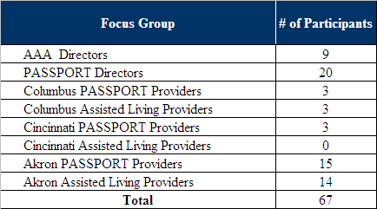

The results of the focus groups conducted during this first phase of the study played an important role in the strengths and weaknesses analysis of the PASSPORT and Assisted Living Waiver programs that are detailed in each Waiver’s respective section later in this report.

A second phase of stakeholder input was conducted with the focus on alternative rate setting methodologies for the PASSPORT and Assisted Living programs. While the sessions held on program strengths and weaknesses were primarily listening sessions for PCG staff, the second round of focus groups involved a different approach.

At the onset of the focus groups, PCG staff provided a presentation that included the following:

- A summary of stakeholder input activities to date;
- An overview of the results of the strengths and weaknesses analysis;
- The results of research conducted on the rate setting methodologies used in peer states;
- Alternative rate setting methodologies for the PASSPORT and Assisted Living programs; and
- An analysis of the pros and cons of each alternative rate setting methodology that had been identified.
After the presentation of alternative rate methodologies, an open discussion took place. Participants asked clarifying questions and expressed their views on the different options that had been presented. In some cases, discussions took place that refined some of the options that had been identified. In other cases, participants suggested approaches to rate setting that added to the list of optional approaches.

The second phase of stakeholder input took place on September 9, 10 and 11 in Columbus. Sessions were held with ODA, ODJFS and OBM staff, the Directors of the Area Agencies on Aging, providers of PASSPORT and Assisted Living services, staff of provider organizations, and advocates. People invited to the provider/advocate sessions included everyone who was invited or attended the regional focus groups held during the first phase of the study. Fifteen people attended the session held for PASSPORT providers and eight people attended the session for Assisted Living providers. All of these sessions took place in Columbus. The results of these sessions were carefully considered in reviewing the analysis of alternative rate setting methodologies and in formulating study recommendations.

Stakeholder input played a very valuable role in this study. A large amount of information was gathered, insights into a variety of aspects of the PASSPORT and Assisted Living programs were gained, the implications of various approaches to rate setting were articulated, and new options were identified. Participants were constructive, candid and fully engaged. PCG staff was very appreciative of the cooperation and attention provided by all who chose to participate.

B. Overview of Strengths & Weaknesses Analysis

As discussed above, PCG gathered stakeholder input through two approaches, individual interviews and regional focus group sessions. The stakeholder participation in this project served to provide PCG with historical and operational overviews of the PASSPORT and Assisted Living Waiver programs. All input gathered has been analyzed and summarized as strengths and needs of the PASSPORT and the Assisted Living Waiver programs.

A systematic approach was taken in conducting the strengths and needs analysis. While much of the analysis is based on stakeholder input, it also reflects PCG’s review of relevant data, comparisons with other states, and general observations. The PASSPORT and Assisted Living analyses are organized according to the following measures:

- Fairness: Does the rate setting methodology result in payments above or below a provider’s expected costs? In addition, how do ODA payment rates compare to the rates paid for comparable services by other payors, such as ODJFS and county levy programs?

- Quality: Does the rate setting methodology consider quality measurements and benchmarks?

- Efficiency: Are individuals who qualify for services receiving those services in an efficient and timely manner? Is the cost of the services reasonable in light of the benefit that individuals receive and are individuals experiencing the anticipated benefits?
- Acceptability: Are the payment rates sufficient to attract the number of service providers needed to meet the demand for services?

- Resource Based: Do payment rates properly account for the differences in the level of care or case mix of service recipients?

- Simplicity: Is the basis of the rate setting methodology understood? Are the administrative burden and process requirements of the rate setting method reasonable from both a provider and state perspective?

- Outlier Recognition: Does the rate setting methodology make reasonable accommodation for outlier situations?

- Compliance: Does the rate setting methodology adhere to CMS guidelines and relevant state statutes and regulations?

The strengths and weaknesses analysis of the PASSPORT and Assisted Living Waiver programs are detailed in each Waiver’s respective section later in this report.

IV. Alternative Rate Setting Methodologies

A. Rate Setting Definitions and Methodologies

Neither the Social Security Act (SSA) nor the Code of Federal Regulations (CFR) specify how much states shall reimburse home and community based providers. Rather, both the SSA and the CFR set general principles to which reimbursement must adhere. For example, the SSA, at section 1902(a)(30)(A), requires the state to:

“provide methods and procedures relating to utilization of, and the payment for, care and services available under the plan ... to assure that payments are consistent with efficiency, economy, and quality of care and are sufficient to enlist enough providers so that care and services are available under the plan at least to the extent that such care and services are available to the general population in the geographic area.”

This language emphasizes that payments must adhere to four principles: efficiency, economy, quality of care, and access. PCG’s discussion of rate setting methodologies in this report will focus on these four principles and how each rate setting methodology can or cannot promote these four principles.

Rate Setting Terminology
Prior to discussing alternative rate setting methodologies, PCG will introduce the terminology of rate setting concepts. A review of Ohio literature and discussions with various stakeholders indicate that reimbursement terms can be used in different ways. To assist the readers of this report, PCG will establish definitions for frequently used terms.

- Budgeted cost: Anticipated or projected amounts that might be incurred for a fiscal period. Not actual costs, even though they are frequently referred to as costs.

- Bidding: Practice of establishing payment rates by collecting bids from potential providers.

- Cost-based: Provider-specific rate determined by using the provider’s own cost experience or budget projections.

- Cost center: An activity, organization, or object for which cost information is collected. Examples include direct service costs, indirect costs, and general and administrative costs.

- Efficiency incentives: Payment of some portion of the difference between an upper limit and actual costs below the limit.

- Flat rates: Rates established by dividing budgeted, available, or historical dollars by case load projections, anticipated units of service, or actual units of services provided. May also be set through negotiation between payers and providers or be dependent upon the persuasive ability of providers to argue for a particular rate.

- Fixed Costs: Expenses that do not change in proportion to the activity of a business.

- Historical cost: Actual cost experience determined from a prior completed fiscal period.

- Marginal Costs: Change in total cost attributable to the production of an additional unit of service.

- Peer groups: Providers with similar characteristics such as size, specialty, ownership, or location; for example, rural or urban.

- Price-based: Standard price established for all providers within the state or peer group. Can be developed based on benchmarks, such as means, medians, or percentiles of the actual cost experience of the provider group. Can also be based on an analysis of a hypothetical provider and the average market prices it would pay for goods and services to produce its products.

- Projected Inflation factors: Factor used to set the amount of money that providers will receive to compensate for changes in their costs during the rate period.

- Prospective reimbursement: Payment of rates based on historical data or budget projections with no subsequent settlement to actual costs.

- Rebasing: Practice of periodically collecting cost information from providers and using the information to change the rates paid.

- Retrospective reimbursement: Payment of a previously established rate that is settled to actual costs at the end of a set period.

- Upper limits (also referred to as ceilings): Maximum amounts per cost center that will be reimbursed; usually arrived at by arraying each provider’s costs in a frequency distribution and picking a point in the distribution such as 115% of the distribution’s median value.

- Variable Costs: Expenses that change in relation to the activity of the business.

Rate Setting Practices
Rate setting systems may be described on three dimensions:

- The degree to which a provider’s experience is considered in the methodology.

A reimbursement methodology may be provider-independent or provider-dependent. Rates that are not based on a particular provider’s costs experience, their charges for services, or their projected costs are provider-independent rates. For example, both flat rate and price-based systems tend to be provider-independent. In these systems, providers are reimbursed according to a set flat rate or an established price regardless of their individual cost experience. If these flat rates are not incrementally adjusted for inflation or rebased, their continued use has the effect of reducing the value of the reimbursement to providers. A provider-dependent rate system is one in which the reimbursement to each provider is linked in some way to its particular historical costs, projected amounts, or bids.

- The degree to which rates are adjusted later based on provider cost experience during the rate payment period.

There is considerable variability in the design of rates and rates can either be retrospective or prospective in nature. Retrospective systems establish an interim rate for a future period by using either budget projections or historical costs of a prior period. After the rate period ends and actual cost experience is determined, there is an adjustment made from interim rates to actual cost experience. In calculating the settlement to actual costs, states frequently set upper limits or ceilings by cost center, paying an amount equal to the lower of the actual cost experience or the calculated upper limit or ceiling. These limits may be established for peer groups or for all providers as a single group. If limits or ceilings are set too low, this retrospective system resembles a price-based system.

Retrospective systems are often more difficult to administer because of the administration of the settlement. In the last ten years, both state Medicaid and federal Medicare payments have moved away from retrospective reimbursement systems.

Prospective systems typically use some combination of budgeted and historical costs trended forward to establish reimbursement rates. Whatever the basis for establishing rates, they are not settled to actual costs at the end of the rate period. Prospective systems can also incorporate upper limits or ceilings. For providers with costs below the upper limits, there may be efficiency incentives. In addition to upper limits, these systems may incorporate lower limits or floors. If there is a floor, the provider is paid its cost or the floor, whichever is greater. The rates for these systems are based on cost reports submitted by the providers. The rate calculation uses allowable costs, as defined by the state, frequently divided into cost centers.

- The degree to which a rate setting methodology is rebased.

Reimbursement methodologies for HCBS vary in the length of time a rate is used. There are no federal requirements that a Medicaid rate be rebased or have an inflation factor added to it. Once set, rates are normally in place for a specified period of time. Following this pre-determined payment period, rates should be evaluated and potentially adjusted for inflation as Ohio has done in recent years by providing a 3% inflation factor. Without rate increases to account for the impact of inflation, providers would need to reduce costs by the amount of inflation in order to maintain an even status. It is important to periodically evaluate the reasonableness of rates and rebase rates, as indicated.

Analyzed Rate Setting Methodologies
As described above, reimbursement methodologies must adhere to the four principles of efficiency, economy, quality, and access. In an effort to compare common rate methodologies, PCG developed a scorecard system to review alternatives as compared to the efficiency, economy, quality and access criteria established by SSA 1902(a)(30)(A) regulations. For purposes of this analysis, PCG defined

- Efficiency as ease of administration;
- Economy as fiscal appropriateness of rates;
- Quality as quality of care; and
- Access as access to services.

In the section that follows, PCG addresses these factors and provides a determination that the method addresses and promotes each function. For each of the factors, PCG has assigned a value according to the list below:

- Yes = 1
- Neutral = 0
- Maybe = -.5
- No = -1

Current Rates
Currently, most of the service rates for the PASSPORT program are set through negotiations with qualified service providers. The negotiations are guided by the regional averages and ceiling rates set by ODA. Some PASSPORT services are flat statewide rates. Assisted Living rates are based on tiered levels of services, with one statewide rate per tier. The 2003 CMS review of the PASSPORT program requested a standardized rate setting methodology to prevent significant rate variances for the same services across the Waiver. Additionally, during stakeholder interviews, PCG noted comments that the current rates may not be sufficient to attract enough providers into the system who are willing to provide quality care. The analysis below addresses the current rate system following the criteria established in SSA.

Service | Compliance | Value | Notes
Efficiency | Yes | 1 | A robust contracting, rate setting, and compliance system is currently in place; changing it would only add cost (short term). However, if the system did change, savings could be realized administratively (long term) due to reduced contract management, streamlined rate maintenance, etc…
Economy | No | -1 | The rates are currently highly variable. The methodology lacks controls over the negotiation process other than regional ceilings. Until a cost study is conducted, PCG is not able to determine the economy of such a change.
Quality | Neutral | 0 | The current rate setting methodology may inhibit quality. For instance, flat statewide rates for Assisted Living services may not be appropriate for certain providers in certain areas. Conversely, Personal Care Services may encourage better quality, as each rate is “best fit” to that providers needs.
Access | Yes | 1 | This methodology encourages provider participation through open enrollment.

Acuity-based Rates
Under a rate setting methodology that links payment rates to acuity measures, the consumer level of care is taken into consideration. That is, the rates would take into account that one consumer may require more attention and services at a higher intensity level than another consumer. Oftentimes this is defined as a case-mix payment (as is available for Adult Day Services under PASSPORT). Adult day services are offered at two levels, enhanced and intensive. It can also be defined by tiers (as is the case with the current Assisted Living Waiver). Assisted Living sets rates based on three tiers that are acuity-based from high to low.

Service | Compliance | Value | Notes
Efficiency | No | -1 | This rate setting methodology may not be the most efficient in that new protocols for establishing “acuity” would need to be developed and then executed for each consumer. This could add administrative burden to the PAAs to evaluate consumers appropriately and also on ODA to monitor the consumer assignments. Although there are cost barriers to implementation, the state, PAAs, and providers could realize long term savings related to acuity-based payment methodology.
Economy | Yes | 1 | Using acuity levels to determine rates of payment could create economies within the system. Theoretically, providers would be reimbursed more for the more complex consumers and less for those that have less service needs. Providers would be compensated adequately for each consumer.
Quality | Yes | 1 | The quality of care could be impacted positively by this rate setting methodology. Providers will be more adequately reimbursed for the level of care being delivered to consumers. This would impact quality of those individuals with more complex needs opposed to those with less complex needs.
Access | Yes | 1 | This methodology could also positively impact access. If providers are being compensated more in line with their costs of providing the service, they could be more willing to provide the service.

Flat Rates (Regional or Statewide)
A rate setting methodology for flat rates involves dividing budgeted or available dollars by caseload projections or anticipated units of service. There is a certain amount of money that is available for PASSPORT and Assisted Living services. The potential number of caseloads or units of service could be divided into that amount of money in order to establish flat rates, if the number of caseloads or units of service are predictable.

Service | Compliance | Value | Notes
Efficiency | Yes | 1 | This methodology could be considered efficient because of its simplicity. The total amount of funding for the PASSPORT program is known and divided by projected unit measures.
Economy | No | -1 | The methodology may not be economic since it assumes that every service is provided the same way, with no variation in consumer acuity or for provider costs.
Quality | Maybe | -.5 | The quality of care for services provided using this rate setting methodology may or may not be impacted. For some services, payment rates may be in line with the actual costs associated with the providing the service, having a positive effect on quality. For other services, the rates may be inadequate, making it difficult for providers to deliver quality care.
Access | Maybe | -.5 | Similar to quality of care, access could be impacted in either direction under this methodology.

Indexed Rates
Under this rate setting methodology, a flat rate for each service would be established. Then, changes to these flat rates are made based on regularly scheduled indexing to inflation such as market basket, wage index, Consumer Price Index (CPI), or other inflationary values. Currently, PASSPORT and Assisted Living systems do not have regular indexing.

Service | Compliance | Value | Notes
Efficiency | Yes | 1 | This is a very simple methodology based on common inflation factors.
Economy | Yes | 1 | ODA would not be overpaying and the cost would be controlled if done regularly.
Quality | Maybe | -.5 | The methodology does not promote quality of care unless rates were regularly reviewed and updated based on cost finding.
Access | Yes | 1 | Regular receipt of an inflation increase promotes access as it creates incentive for more providers to enter the system if they know that their efforts will be recognized and taken into consideration for reimbursement purposes.

Peer Group Rates
Under this rate setting methodology, providers with similar characteristics are grouped together and rates are established for each peer group. In this way, provider differences are taken into consideration. Potential peer groups can be developed based on number of consumers serviced, number of employees, specialty, ownership, or location, e.g. rural or urban. Data would need to be collected from providers in order to establish the most appropriate peer groups.

Service | Compliance | Value | Notes
Efficiency | No | -1 | This methodology will have considerable start-up cost but could eventually lead to efficiencies.
Economy | Yes | 1 | Depending on the determinants of the peer groups, economy can be achieved through this methodology in that providers with like characteristics may have similar cost structures.
Quality | Neutral | 0 | If the determinants are selected to meet the needs of the majority of providers and rates are set appropriately to meet needs, quality can be positively impacted.
Access | Neutral | 0 | Similar to quality of care, peer group rates can entice providers to serve clients if the peer groups are established appropriately.

Cost-Based (Retrospective)
A cost-based reimbursement methodology determines provider-specific rates by using the provider’s own cost experience or budget projections. Providers would be asked to complete a cost report to allow ODA to understand actual provider costs, regional variations in cost of living or wages, and cost sensitive population demographics. Rates would then be set with the provider’s costs in mind so that they are adequately reimbursed for the costs they incur providing services. At the end of the period, cost settlements would be made based on the providers cost experience.

Service | Compliance | Value | Notes
Efficiency | No | -1 | Without the proper controls, provider specific cost-based methodologies promote inefficiencies.
Economy | No | -1 | Without controls, this is not economical.
Quality | Neutral | 0 | Without controls, it cannot be proven this has a positive impact.
Access | Yes | 1 | Providers would have incentives to join the system.

Cost-Based (Prospective)
A prospective cost-based reimbursement methodology could determine rates by using the provider’s own cost experience to develop a fee schedule. This methodology could include regional variations in cost of living or wages, acuity, and cost sensitive populations. Rates would be developed based on cost finding and applied prospectively. No cost settlements would be made at the end of the period.

Service | Compliance | Value | Notes
Efficiency | Neutral | 0 | Completing a cost study would be costly (short term) but prospective rate development would create efficiencies (long term).
Economy | Yes | 1 | Providers would be forced to operate within predetermined cost-based limits adjusted for acuity, peer groups, etc…
Quality | Yes | 1 | Prospectively developed cost-based rates would ensure providers are fairly and reasonably reimbursed for services, enhancing quality of care through investment in resources and capital.
Access | Yes | 1 | Because of the cost-based component, providers would have incentives to join the system.

Summary
Based on PCG’s assessment, Acuity-based, Indexed, and Cost-Based (Prospective) rates are most positively correlated to the Medicaid rate setting tenets of efficiency, economy, quality, and access. Flat and Cost-based (Prospective) rates were the most negatively correlated to these same tenets. The results of this exercise are consistent with recent best practice and CMS audits of the past several years and should be considered seriously by ODA when selecting methodologies for each rate methodology. Each methodology is different and should be considered independently when making decisions on implementation. The recommendations section of this report builds on this analysis and provides more direct recommendations for each service provided under PASSPORT and Assisted Living Waivers.

Methodology | Efficiency | Economy | Quality | Access | Total
Current Rates | 1 | -1 | 0 | 1 | 1
Acuity-based Rates | -1 | 1 | 1 | 1 | 2
Flat Rates | 1 | -1 | -.5 | -.5 | -1
Indexed Rates | 1 | 1 | -.5 | 1 | 2.5
Peer Group Rates | -1 | 1 | 0 | 0 | 0
Cost-Based (Retrospective) | -1 | -1 | 0 | 1 | -1
Cost-Based (Prospective) | 0 | 1 | 1 | 1 | 3

B. Alternative Rate Methodologies in Ohio

Ohio Waiver Reimbursement Methodologies
Within Ohio there are six other Waivers and programs that provide similar services to PASSPORT throughout the state. ODJFS administers the Ohio Home Care and Transitions Waiver and the Ohio Department of Mental Retardation & Developmental Disabilities (OMRDD) administers an Individual Options Waiver and Level One Waiver. Below is a table that depicts the services offered within each Waiver.

Table 3: Summary of Ohio Waiver Services
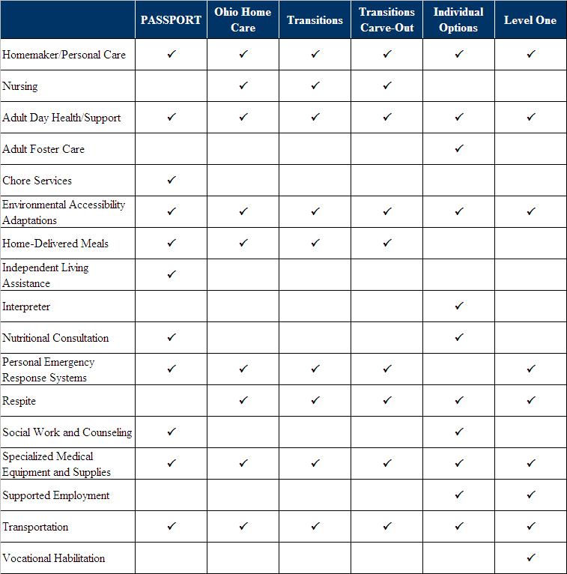

ODJFS Waivers

Ohio Home Care Waiver
The Ohio Home Care Waiver (OHCW) is for Ohioans fifty-nine years and younger, which meet specific financial criteria and need an intermediate or skilled level of care. The following is a summary list of services provided under the OHCW and definitions according to OAC 5101:3-46-04:

- Waiver Nursing Services: Services provided to a Waiver consumer by an RN or LPN skilled nurse. The Waiver nursing service provider can also be reimbursed for personal care aide services, as each service can coincide with the other.
- Personal Care Aide Services: Assisting the Waiver consumer with Activities of Daily Living and assisting with activities of daily living impairments.
- Adult Day Health Center Services: Regularly scheduled services that are delivered at a day health center to consumers 18 or older.
- Home Delivered Meals: Provision of individual meals to a consumer, which are safe and nutritious. Meals must be planned by a dietician.
- Home Modification Services: Environmental accessibility adaptations to elements of the Waiver consumer’s home that allow greater functionality for independent living.
- Supplemental Transportation: Transportation otherwise not covered by Medicaid that enables a consumer access to Waiver services and other community services.
- Supplemental Assistive and Adaptive Device Supplies: Devices that would allow the consumer more independence.
- Out-of-Home Respite Services: Services provided to a consumer in an out-of-home location to provide respite to caregiver.
- Emergency Response Services: Twenty-four hour communication connection systems.

The billing and reimbursement process for the OHCW requires documentation for all service providers. For example, a personal care aide must submit the following for each claim: documentation with the date and time of service and delivery, the services performed, and signatures of the personal care aide and consumer.
Table 4: Comparison of Ohio Home Care and PASSPORT Personal Care Services
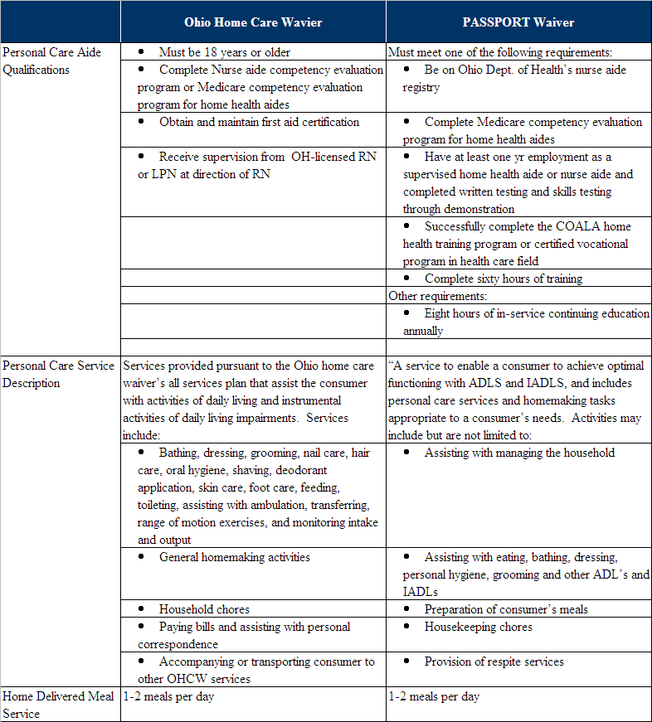
Data Source: PASSPORT Personal Care Service Data from OAC 173-39-02.11.
Ohio Home Care Waiver data from OAC 5101:3-46-04)

Transitions and Transition Cave-Out Waiver
ODJFS also administers the Transitions Waiver and the Transitions II Carve-Out Waiver. The Transitions Waiver is designed for consumers of all ages that would be eligible for the Ohio Home Care Waiver but have been transferred due to a need for intermediate care facility services for people with mental retardation. The Transitions II Carve-Out Waiver is available only to those aged sixty and above who transferred from the Ohio Home Care Waiver. This Waiver offers the same services as the Ohio Home Care Waiver and is currently closed to new enrollment.

Reimbursement Methodology
The table below notes the rates for the various services that are provided through the Ohio Home Care Waiver, Transitions and Transitions II Waivers. All three of these Waivers provide the same services and service rates.

The methodology for reimbursement is that a service has a statewide base rate. The base rate is the maximum amount that ODJFS will pay for up to an hour of service. Any additional time after the initial hour is considered a unit. The units are 15-minutes long, which are added to the base rate, to sum a total reimbursement for the service provided.

Table 5: Comparison of Ohio Home Care and PASSPORT Reimbursement Rates
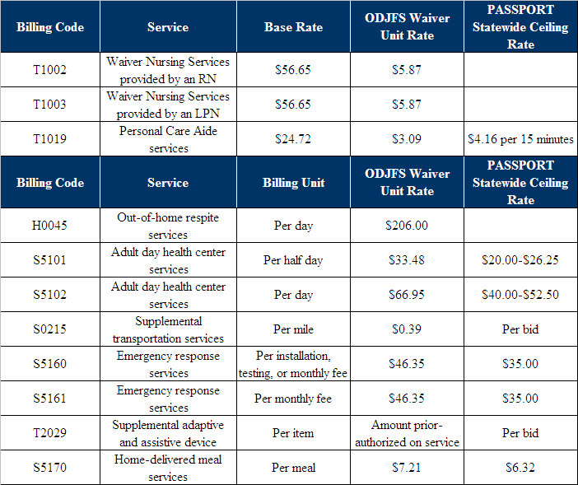

Ohio Home Care Program (State Plan Services)
Services are available through the Ohio Home Care Program as for those not enrolled in a Waiver program. The services provided are nursing, daily living, and skilled therapies. To be eligible for these services, the consumer must: have an inpatient hospital stay for three or more days; have a comparable level of care that is evidenced by enrollment in a Waiver or have a temporary impairment and need an institutional level of care; and have a need for skilled nursing or therapies at least once per week. All Ohio Home Care Program Service Providers must be from a Medicare Certified Home Health Agency.

The services provided through the Ohio Home Care Program are summarized as follows:

- Home Health Nursing- service that requires skills of Registered Nurse or licensed nurse under the direction of an RN.
- Home Health Aide- provides services that are medically necessary for the health of the consumer, i.e., Bathing, dressing, grooming, hygiene, including shaving, skin care, foot care, ear care, hair, nail and oral care, that are needed to facilitate care or prevent deterioration of the consumer’s health, and including changing bed linens of an incontinent or immobile consumer.
- Skilled Therapies- Licensed Physical Therapists, Occupational Therapists, Speech-language pathologists, Licensed Physical Therapist Assistants LPTAs.

The reimbursement methodology used by ODJFS in administering the non-Waiver Ohio Home Care Program is based on a system of rates that are in the table below. Each visit, according to the Ohio Administrative Code, must be no more than four hours. For a visit that was less than an hour long, the maximum Medicaid reimbursement rate would be the Base rate. For a visit that is greater than one hour, the maximum rate is determined by adding incremental “unit rates” which equal 15 minutes to the base rate for one-hour.

Table 6: Ohio Home Care Program (State Plan Services) Reimbursement Rates
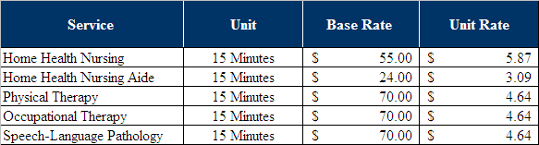
Data Source: Adapted from the OAC 5101:3-12-05 Reimbursement: home health services http://codes.ohio.gov/oac/5101%3A3-12-05

ODMRDD Waivers
Currently, the Ohio Department of MRDD administers two Waivers: the Level One Waiver and the Individual Options (IO) Waiver. The Level One Waiver, as described in the Level One Guide, is for consumers with mental retardation or developmental disabilities that are receiving treatment at an Intermediate Care Facility and would like to receive their treatments at home. The services can be provided by Medicaid providers or family and friends of the consumer. The consumer has access to up to $5,000 per year for personal care or homemaker services. Additionally, every three years, the consumer may receive personal emergency response systems, environmental accessibility systems, and specialized medical equipment and supplies. If the client is an adult, they have access to Adult services as well.

The Individual Options (IO) Waiver is also for the population with mental retardation and/or developmental disabilities. The IO Waiver is similar to the Level One Waiver in that it allows the consumer to receive services at home. The consumer may stay at home under this Waiver rather than entering an intermediate care facility.

ODMRDD Reimbursement Methodology
The reimbursement amount for ODMRDD Waivers depends on four variables:

1) ODDP funding range of the individual;
2) Number of individuals who share the service, regardless of funding source;
3) Cost of doing business factors of the county; and
4) Provider type (agency or individual.)

Ohio Developmental Disabilities Profile (ODDP)
The Ohio Developmental Disabilities Profile (ODDP) is an assessment tool and the first step of the reimbursement methodology. The reimbursement process is based on the service needs of the individual. According to ODMRDD, ODDP allows individuals with similar needs and circumstances to access comparable levels of Waiver services throughout Ohio. The reimbursement methodology starts with the consumer filling out an ODDP, after which an Individual Service Plan (ISP) is developed.

Individual Funding Level
The Individual funding level is a result of the completion of the ODDP and an ISP, as defined in OAC 5123:2-9-06:
(7) “Individual funding level” means the total funds that result from applying the rates in appendix A to this rule to the units of all Waiver services except for day habilitation and supported employment that have been determined through the individual service plan (ISP) development process to be sufficient in amount, duration and scope to meet the health and welfare needs of an individual. Unless prior authorization has been obtained in accordance with rule 5101:3-41-12 of the Administrative Code, the individual funding level for services reimbursed in accordance with this rule except supported employment shall be within or below a funding range assigned to the individual as the result of administration of the ODDP.

Rates
The following table depicts the rates for the Individual Options and Level One Waivers. These rates are used to create an individual funding level as described above, and serve as the Medicaid reimbursement rates. This table shows Agency Providers (AP) and Non-Agency Providers (non-AP), services, billing units, service codes and base reimbursement rates according to OAC 5123:2-9-06. The base reimbursement rates are a range of the base rates for the state. Under these regulations, interpreter services, nutritional services, social work services, and, homemaker/personal care services have payment rates that reflect provider certification types and geographic variations.
Table 7: Individual Options, Level One and Level One Emergency Assistance Waiver Rates
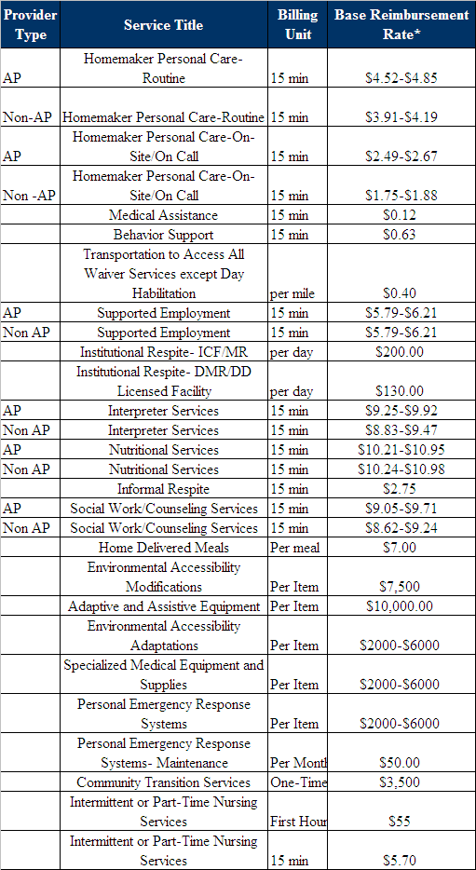
Data Source: OAC 5123:2-9-06, Appendix A, http://www.registerofohio.state.oh.us/pdfs/5123/2/9/5123$2-9-06_PH_FF_A_APP1_20080310_0820.pdf

Cost of Doing Business Categories
As mentioned above, there are eight geographically assigned Cost of Doing Business (CDB) categories. These categories were the result of cost reports completed for 2002, by service providers and reflect actual costs. Counties are divided among eight different CDB categories according to a weighted average of dollars spent submitted in 2002 claims. The counties that are in the same CDB category set the same base rate and incremental weighted adjustments.

The following table depicts the Cost of Doing Business categories according to OAC 5123:2-9-06 HCBS Waivers - Waiver reimbursement methodology.

Table 8: MRDD Cost of Doing Business Categories
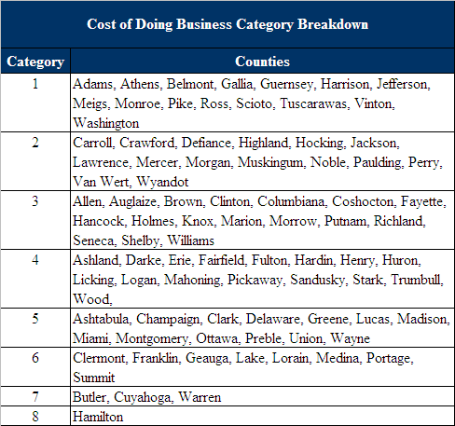

An example of the variation of rates among categories is the personal care service that is provided by the Level One and Individual Options Waiver. The following is the base rates for personal care for the eight groups.

Table 9: MRDD Cost of Doing Business Categories Rates of Reimbursement
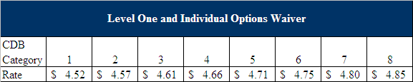

Under this methodology, a single provider may charge different rates for the same service when the service is provided in different geographic areas of the state. In this instance, the UCRs (Usual and Customary Rates) charged are supposed to be declared for each cost of doing business category shown above that identifies the counties in which the provider intends to provide specific services. Upon notification of a provider’s UCR or change in UCR, the department is supposed to provide notice to the appropriate county board. Similar to all Waiver programs, providers are then reimbursed at the lesser of their charge for the service or the statewide payment rate for the service that is delivered.

Other Facts about Level One and Independent Options Waivers
- ODMRDD/ODJFS utilizes a “Payment authorization for Waiver services (PAWS)”
- There is an add-on charge for Medical Assistance and Behavior Support for Homemaker/Personal Care Routine Services in the in the event that a consumer needs extra support.
- There is a system in place to address inadequately assigned Individual Funding Levels.

Ohio Tax Levy
A unique aspect of Ohio’s funding for senior services stems from its county levy system. The March 2006 Senior Levy Report, by the Ohio Association of Gerontology and Education (OAGE) provides detailed information on the history and usage of the senior service tax levy. More recent data, available on the ODA website states that sixty-seven out of eighty-eight Ohio counties have a county-wide property tax senior service levy based on the fair market value of real estate. Additionally, municipalities, townships and villages also use local property tax levies to increase and expand services to older adults. A tax levy is voted on and is in effect for up to five years. Only seven other states have a senior tax levy system: Illinois, Kansas, Louisiana, Michigan, Missouri, Montana, and North Dakota.

While the levy does not directly fund consumer services, the levy provides funding for senior services agencies within the county, municipality or town. This additional funding is essential to recipients of home care based services because it provides a continuum of care through both medical and social services.

The March 2006 report notes the four ways that counties may distribute the senior service tax levy:

- Single/Several recipients for a multi-purpose senior center. The senior center typically serves as the major center for meals, transportation, home repairs and outreach.
- County government distribution in the form of a grant to a direct service organization.
- Independent Council on Aging which focuses on development, coordination and operation of services for older adults. Such councils may use funds to offer special grants themselves, provide some direct services, assist with senior clubs and interest groups, and/or provide case management.
- Area Agency on Aging which administer programs through local organizations and businesses as service providers.

The levies generate more than $127 million per year. According to the ODA website, the highest per capita levy is in Butler County that averages $388 per person over age 60, with Delaware, Warren, Franklin, and Hamilton Counties as the following highest per capita levies. The services that are most often funded are nutrition, transportation, in-home services and senior center administration. Tax levies are usually highly supported by the general public because of their low millage rate and perceived value of services.

It is critical to understand the senior service tax levy to see its relationship with the PASSPORT rate setting process. Being that the most often funded services under the levy (nutrition, transportation, and in-home services) are also provided under the PASSPORT Waiver, there is competition between how the rates are set that could advantage providers. For example, information provided by the Council on Aging of Southwest Ohio indicated that PASSPORT reimbursed approximately 50% less per hour for personal care services ($17.40 for PASSPORT versus $25.72 for Clinton ESP). Such differences in rates could create quality and access issues for PASSPORT clients.

C. Peer State Analysis

Methodology
As part of the effort to identify alternative approaches to rate setting, PCG researched the rate setting methods of selected peer states to understand alternative reimbursement practices used in other rates for programs similar to PASSPORT and Assisted Living Programs. PCG worked with ODA staff to select the appropriate peer states to research and compare eligibility criteria, rate setting methodologies, and reimbursement rate structures. Considerations for selecting these seven peer states included geography, demographics, history of individual’s states’ waivers, and examples of states cited as national models.

PCG researched each peer state’s Medicaid Waiver eligibility criteria and rate setting methodologies. PCG interviewed peer states, extracted information from each state agency’s Web site, professional journal articles, and research papers, as well as actual long-term care Medicaid Waiver forms, where available.

The seven peer states researched for this project include:

- PASSPORT-Related Programs
  - Indiana
  - Pennsylvania
  - West Virginia

- Assisted Living Programs
  - Illinois
  - New Jersey
  - Oregon
  - Washington

For each state, PCG reviewed information on the following topics:

- Scope of Program: Information about services provided, recent legislation, caseload and history of the program.
- Eligibility Criteria: Criteria necessary for consumers to be able to participate in the program.
- Rate Setting Methodology: Information about the methodology each state uses to calculate and set its rates.
- Medicaid Payment Rate: Information regarding the actual payment rates and, when available, the methodology used to establish reimbursement rates.

Overall Findings

As a result of PCG’s peer state analysis, PCG found that

- ODA long-term care Medicaid Waiver program eligibility requirements are consistent with peer states for both Assisted Living and home and community-based long-term care;
- ODA payment rates for long-term care Medicaid Waiver programs are inconsistent with peer states; and
- Peer states use an array of methodologies to set reimbursement rates for long-term care program waivers, including regional rates, functional criteria using Activities of Daily Living (ADL), scores based rates derived from a number of factors defined and determined by the state, and medical criteria only allowing admission to a facility when nursing care is required on a daily basis.

Ohio’s PASSPORT program and the peer states’ PASSPORT-related HCBS programs provide relatively similar services to Medicaid Waiver consumers; however, the reimbursement rates are structured quite differently between Ohio and its peer states. While Ohio uses a regional rate setting approach, peer states use the provider cost information to set a flat reimbursement rate for each unit of service.

Ohio’s Assisted Living Medicaid Waiver program provides relatively similar services compared to the peer states. Peer states provide social work services, as well as social and medical transportation. Peer states set their rates prospectively based on provider cost information.

Illinois has a flat rate that takes into account regional variations. New Jersey, however, uses a flat rate reimbursement method for both Assisted Living facilities and comprehensive personal care homes. Oregon uses a tiered rate setting approach that takes into account the types of services a Medicaid Waiver consumer will need while in an Assisted Living facility. Washington’s rate setting approach takes into account the type of care Medicaid consumers will need, as well as the region in which the Assisted Living facility is located.

The following sections will describe peer state programs and methodologies in detail.

PASSPORT-Related Programs
The chart below shows the rate reimbursement type for services provided by each state’s PASSPORT-related HCBS Waiver program.

Table 10: Reimbursement Methodology for PASSPORT and PASSPORT-Related Services

Note: PCG was not able to obtain information on Pennsylvania’s HCBS Waiver Services.

Please see Pennsylvania’s section for further information.

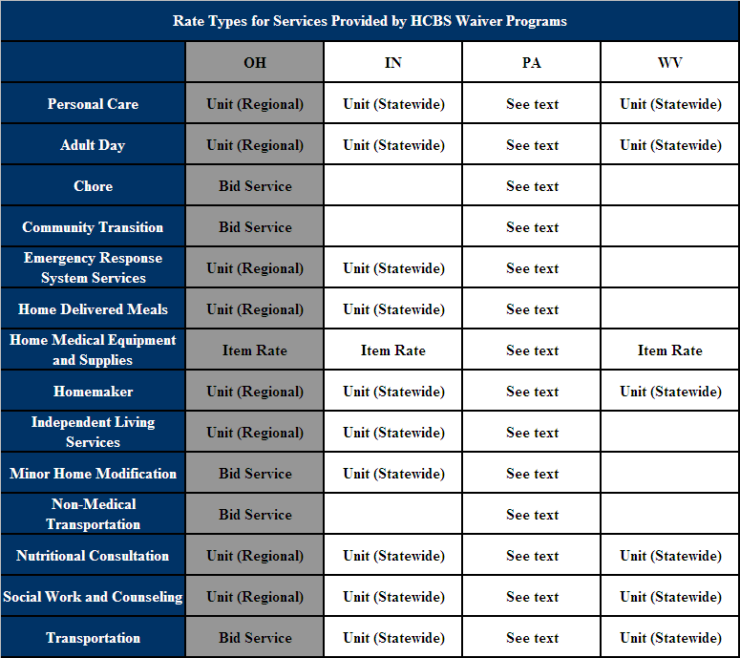

Indiana

Scope of Program
Indiana has a large state-funded HCBS program. As a result, Indiana allocates a greater portion of its Medicaid long-term care spending for older people and adults with physical disabilities to nursing homes. The program, known as CHOICE, sees enrollment increases each year, with a large number of individuals (approximately 6,000) on the waiting list. In July 2005, Indiana developed a plan for reforming its long-term care system by integrating HCBS, nursing facility care, and hospice into a single long-term care program called Indiana Options for Long Term Care (OPTIONS).

Medicaid Waiver Eligibility Criteria
To be eligible for CHOICE services, consumers must:

- Be an Indiana resident;
- Have (or get) a Social Security Number;
- Be age 65 or older;
- Require institutionalization in the absence of home-based services (must meet 3 of 14 levels);
- Have income that does not exceed $1,635 a month; and
- Have resources that not exceed $1,500.

Medicaid Rate Setting Methodology
CHOICE agencies are reimbursed for covered services provided to Medicaid recipients through standard statewide rates. These rates equal the total reimbursement per visit, which is calculated as:

(one overhead cost rate/provider/recipient/day) + (staff cost rate * number of hours spent in performance of billable patient care activities)

The overhead cost rate is a flat, statewide rate based on 95 percent of the sate median overhead cost per visit.

The staffing cost rate is a flat statewide rate based on 95 percent of the statewide median direct staffing and benefits cost per hour for each of the following disciplines:

- Registered nurse,
- Licensed practical nurse,
- Home health aide,
- Physical therapist,
- Occupational therapist, and
- Speech pathologist.
Rate setting is prospective, based on the provider’s initial and annual cost report of the most recent completed period. In determining prospective allowable costs, each provider’s cost from the most recent completed year is be adjusted for inflation using the Center for Medicare and Medicaid Services Home Health Agency Market Basket index.

The following chart details payment rate for Indiana’s home and community based services program, CHOICE:

Table 11: Indiana CHOICE Reimbursement Rates
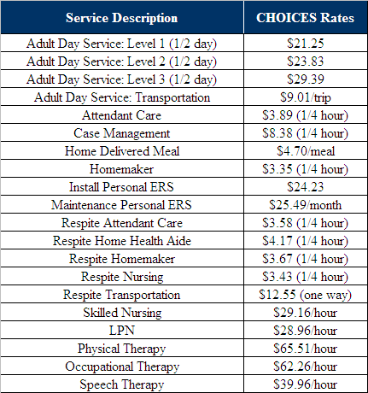

Pennsylvania

Scope of Program
Pennsylvania has two HCBS Waiver programs; Medicaid and a state-funded program that has fewer restrictions on the income eligibility criteria. The state funded program is supported by the lottery with each county getting a certain lump sum of money to provide services and reimbursement rate at their discretion. The state funded program served about 52,000 older people and adults with physical disabilities in 2006, while the Medicaid Waiver program served about 23,000 people the same year.

Medicaid Waiver Eligibility Criteria
To be eligible for Pennsylvania HCBS Waiver services, consumers must:
- Be age 60 or older;
- Have income equal to or less than 300 percent of the Federal Benefit Rate;
- Have a level of care for a Skilled Nursing Facility;
- Have resources less than $2,000; and
- Be served at a cost not to exceed 80 percent of the average MA payment for nursing facility services.

Medicaid Rate Setting Methodologies and Medicaid Rates
Pennsylvania’s Medicaid home and community based services, rates, and rate setting methodologies are designed and implemented at the county level. Pennsylvania has 52 Area Agencies on Aging and, therefore, 52 rates and rate setting methodologies for Medicaid Waiver services. Counties are given complete autonomy in setting Medicaid Waiver rates. As a result, the State is reportedly unaware of what the rates are and how they are set. The Center for Medicaid and Medicare Services (CMS) has asked the state Office of Long Term Living to create a statewide rate by July 2008, according to a Pennsylvania Homecare Association administrator.

Services provided by Medicaid programs include specialized medical equipment and supplies, daily living services, environmental adaptations, personal Emergency Response Systems (PERS), respite services, service coordination, therapies (behavior, occupational, physical, speech), transportation services, and visiting nurse services.
In recent years, the number of participants receiving HCBS decreased significantly faster than the number in nursing homes due to a state-wide oversight program implemented in 2006. The state required all home and community based services care plans valued at $55 to $95 per month to be approved by a regional oversight manager; care plans valued at $95 or more per month to be approved by a Harrisburg oversight manager; and care plans less than $55 per month to be approved on site. Consequently, many counties began to spend less on HCBS due to the extra paperwork and wait time required for services valued at more than $55.
In 2007, Pennsylvania created the Office of Long Term Living to consolidate all LTC programs and services for older people and people with physical disabilities under a single management umbrella. By providing services and information through a centralized office, Pennsylvania aims to keep more residents in their homes receiving long term care services. Additionally, Pennsylvania reportedly plans to begin work on creating a state-wide rate setting methodology.

West Virginia

Scope of Program
West Virginia spends a disproportionately larger amount of Medicaid on nursing facility services compared to HCBS. In 2006, the increase in Medicaid spending on nursing facilities was larger than the total home and community based services spending. In response, West Virginia developed a Transition Initiative in spring of 2007 to provide transition services for nursing home residents who want to return to the community. The plan aims to move at least 50 people within the first year.

Medicaid Waiver Eligibility Criteria
To be eligible for home and community based care services, consumers must:

- Be a West Virginia resident;
- Have (or get) a Social Security Number;
- Be age 65 or older;
- Have income that does not exceed $1,869 a month;
- Have resources that do not exceed $2,000; and
- Meet nursing facility level of care criteria.

Medicaid Rate Setting Methodology
In November 2006, West Virginia’s Department of Health and Human Resources (DHHR) implemented a new Waiver rate setting methodology. West Virginia’s DHHR assembled a Rate Setting Work Team to design the new methodology. Rates are based on Department of Labor wage classes adjusted annually for inflation. Fringe benefits and administration percentages, which are included in the rate setting methodology, come from the community mental and home health centers cost reports as filed with West Virginia health care authority. Finally, annual training, leave and holiday is a negotiated amount, sixteen hours of mandatory training and seven days of annual leave, between the state and health agencies.

The following table provides information on the Waiver rate for one-time services often required in the assessment phase to determine if a consumer is eligible for home and community based care services and if so, what services the consumer will need:

Table 12: West Virginia Reimbursement Rates for One-Time Services
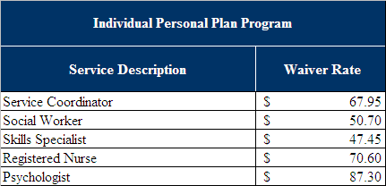

The next table details the payment rate for services provided through West Virginia’s home and community based care services program:

Table 13: West Virginia HCBS Reimbursement Rates
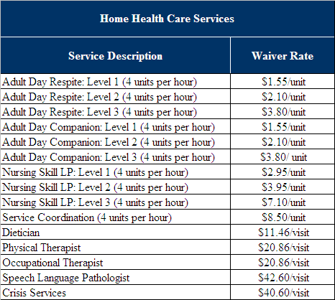

Assisted Living Long-Term Care Programs
The chart below compares Ohio’s rate reimbursement structure for Assisted Living long term care programs to the four peer states.

Table 14: Reimbursement Approaches for Assisted Living Services
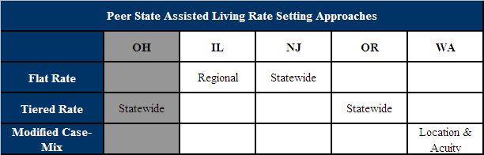

The next chart details the services provided by Ohio, as well as each peer state’s Assisted Living long-term care program.

Table 15: Reimbursement Methodology for Assisted Living Services
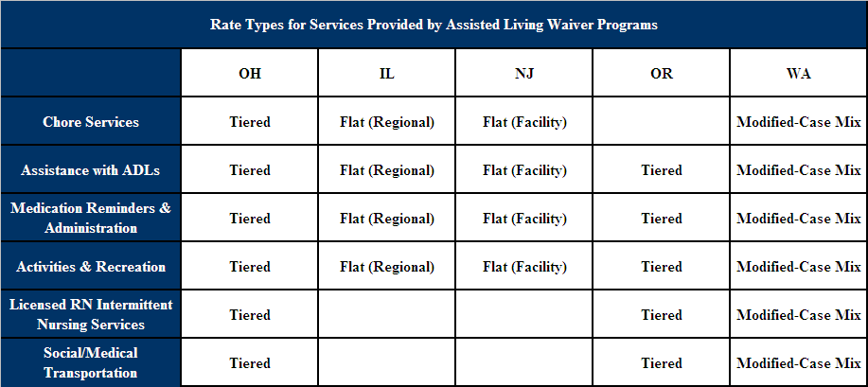

Illinois

Scope of Program
Illinois state law does not allow Medicaid to cover services in Assisted Living establishments; however, a “supportive living facility” (SLF) program has been implemented in certified locations that offer similar services. SLF’s are certified by the Department of Healthcare and Family Services (DHFS) and, as a result, SLF’s are not subject to public health inspections. A SLF may be converted from a nursing home or free-standing buildings that integrate housing, health, personal care and supportive services in home-like residential settings. A maximum of 2,750 Medicaid residents can be served under Illinois’ 1915(c) Waiver.

The program serves elderly and disabled Medicaid beneficiaries who need assistance with ADLs, targeting individuals who are unable to remain in their homes. Services include three meals per day, housekeeping and laundry, security, assistance with ADLs, and medication reminders and administration.

Medicaid Eligibility Criteria
To be eligible for Assisted Living services, consumers must:

- Be age 65 or older;
- Have income no less than the current maximum allowable amount of Supplemental Security Income (SSI) $637. Residents must contribute all but $90 each month to provider for meals, lodging and services.
- Have a Determination of Need (DON) score of 29 or more, which is derived from:
  - Functional Measures:
- Rate by level of impairment (0-3) and unmet need for care (0-3);
- Need for assistance with six Activities of Daily Living (ADLs);
- Need for assistance with nine Instrumental Activities of Daily Living (IADLs).
  - Cognitive Impairment Criterion:
- Mini-mental State Examination (MMSE) a score of 20 or less is counted as 10 points toward DON score.

Medicaid Rate Setting Methodology
The Department of Healthcare and Family Services collects cost reports for nursing home facilities and supportive living facilities on an annual basis; however, rates are only rebased when the state legislature mandates. Rates were rebased in January 1994, July 2001, and January 2008. Cost reports are collected as hard copies, as well as an electronic Microsoft Excel workbook that is uploaded into a Microsoft Access database by the DHFS. A team of one manager, two supervisors and four auditors upload and analyze annual cost reports.

In establishing fixed rates of reimbursement, the Department takes into account the cost information provided by service providers, current market conditions and trend analyses. The reimbursement rate is set at 70% of the nursing home rate based on nursing home cost reports. Consequently, supportive living facility cost reports are not used to set SLF rates; the Department collects SLF cost reports mainly for data purposes. Illinois is slated to begin the process of phasing in minimum data set (MDS) rules.

Table 16: Illinois Regional SLF Rates
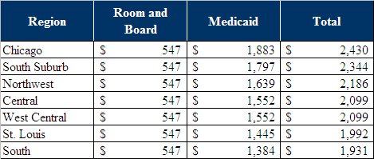

If an SLF applies for a new rate, the Department will consider reimbursing a provider at a rate other than the established fixed rate to compensate for contract-specific variations in cost. An example of this is if there is evidence to suggest that the contract area currently served by a provider will become “unserved” due to inadequate reimbursed by the State to cover costs.

The calculated reimbursement rate has three components:

- Nursing and Direct Care Component: Include costs associated with direct care, nursing, and other group care related health and treatment services. The rate includes payment for assisting patients in meeting basic functional and special health needs and for rehabilitative and restorative nursing care.
- Support Service Component: Covers the general service and administrative costs associated with residential care. It includes costs of food, laundry, housekeeping, utilities, maintenance, administration, insurance, dietary, and general office services. These are costs that do not vary significantly with varying patient need levels.
- Capital Component: Includes costs such as mortgage interest and asset depreciation, but does not use these “costs” in the rate calculation. The rate is calculated based upon a blending of:
  - The inflated historical cost per bed of the building; and
  - The uniform cost per bed for all facilities in the same age and region.

Illinois has fixed rate reimbursement system based on the geographical area in which the service is provided.

The room and board payment is equal to the current Supplemental Security Income (SSI) benefit minus a $90 Personal Needs Allowance (2008 rate: $547.00). Therefore, Medicaid does not pay the costs of room and board; rather, residents pay this cost through the SSI payment. During a temporary absence, all bed reservations must be authorized by a physician; have post-payment approval from Bureau of Long Term Care staff, limited to residents who desire to return to the same facility; and are limited to facilities having a 93% or higher occupancy level with 90% of that occupants being Medicaid-eligible. The occupancy level is calculated including both payable and non-payable bed reservations as occupied beds.

New Jersey

Scope of Program
The state of New Jersey has Assisted Living residences (ALR) and comprehensive personal care homes (CPCH), both of which are licensed facilities by the Department of Health and Senior Services (DHSS) that provide Assisted Living services. ALRs are apartment-style housing with a private bathroom and kitchenette, while CPCHs offer bedrooms with shared bathrooms and no kitchenette. Services provided in these facilities include three meals per day, housekeeping and laundry, assistance with ADLS, and medication reminders and administration.

The legislature passed a law requiring that facilities licensed after September 2001 set aside 10% of their units for Medicaid beneficiaries within three years of licensure. Additionally, all new construction is “purpose-built, apartment-style” units. Only facilities licensed by the DHSS prior to December 1993 can convert to CPCHs.

Medicaid Waiver Eligibility Criteria
To be eligible for Assisted Living services, consumers must :

- Be age 65 or older;
- Have gross monthly income at or below $1,911 per month;
- Have resources at or below $2,000; and
- Have either nursing needs, functional needs or a combination of both:
    - Must need at least 2.5 hours of nursing service a day;
    - ADL dependencies; including need for supervision, oversight, encouragement, or cueing; and/or
    - Memory problems that compromise personal safety

Medicaid Rate Setting Methodology
The Medicaid Waiver services daily rate is based on a 1994 capital outlay rate. The New Jersey DHSS assigned a daily rate based on the type of building where services occur:

- Assisted Living Residence (private bathroom and kitchenette): $60 per day
- Comprehensive Personal Care Home (shared bathroom and no kitchenette): $50/day
- Assisted Living Program (often takes place in publicly subsidized housing): $40/day

As the result of provider frustration, the state increased the daily rates by $10 across the board in January 2001.

The room and board rate is the current monthly Supplemental Security Income (SSI) benefit minus a personal needs allowance for $83.50 (2008: $553.50). The room and board rate is rebased annually when the SSI benefit increases. Therefore, Medicaid does not pay the costs of room and board; rather, residents pay this cost through the SSI payment. If residents do not have enough money each month to meet the room and board requirement, they can apply for an optional state supplement to meet the costs.

The state of New Jersey does not have a bed-hold policy. Facilities can implement bed-hold policies at their discretion. The Department only mandates that facilities must inform residents of their bed-hold policy.

Assisted living facilities and comprehensive personal care homes are not required to produce cost reports to the DHSS.

Table 17: Breakdown of New Jersey Assisted Living Expenses
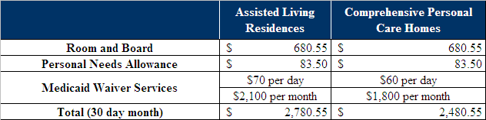

Oregon

Scope of Program
Oregon does not allow providers to market themselves as Assisted Living unless they offer residents private apartments and are licensed as Assisted Living facilities. In 2001, a moratorium was placed on licensing of new ALFs until June 30, 2009. New applicants requesting licensure must demonstrate that the proposed facility will serve a population for whom insufficient services exist in the service area. The rule now allows facility to request an increase in capacity by 10%.

Medicaid Waiver Eligibility Criteria
To be eligible for Assisted Living services, consumers must:

- Be age 65 or older;
- Have income that does not exceed 300 percent of SSI. Residents are permitted to retain $565.70 ($455.70 for room and board and $82 for personal needs) as a maintenance allowance and the remainder is the residents’ cost sharing amount;
- Need services based on a certain amount or combination of ADLs. Eligibility is limited to Levels 1-13:
  - Dependent in mobility, eating, toileting, and eating and cognition;
  - Dependent in mobility, eating, and cognition;
  - Dependent in mobility or cognition or eating;
  - Dependent in toileting;
  - Substantial assistance with mobility, assistance with toileting and eating;
  - Substantial assistance with mobility and assistance with eating;
  - Substantial assistance with mobility and assistance with toileting;
  - Minimal assistance with mobility and assistance with eating and toileting;
  - Assistance with eating and toileting;
  - Substantial assistance with mobility;
  - Minimal assistance with mobility and assistance with toileting;
  - Minimal assistance with mobility and assistance with eating;
  - Assistance with toileting;
  - Assistance with eating;
  - Minimal assistance with mobility;
  - Full assistance with bathing and dressing;
  - Assistance in bathing or dressing; and
  - Independent in the above levels, but requires structured living for supervision for complex medical programs or a complex medication regimen.

Medicaid Rate Setting Methodology
Oregon has five payment levels based on the type and degree of residents’ impairments and the type of community-based care facility (residential care Assisted Living) where the care is delivered. ADLs assessed include eating/nutrition, dressing/grooming, bathing/personal hygiene, mobility, bowel and bladder control, and behavior. Reimbursement rates are uniform throughout the state based on the type of community-based care facility. For community-based care, the basic rate is the default rate. Depending on the need, the individual may qualify for one of three add-on payments. The add-ons are for specific ADL, Behavioral or Complex Medical needs. Add-ons are automatically added to the rate if certain conditions are met based on the assessed needs. There is no process for requesting add-ons to the assessed rate.

The state limits the room and board payment to $483.70, which is less than the full Supplemental Security Income (SSI) payment, allowing the beneficiary to retain the balance of the SSI payment as for a personal needs allowance.

Additionally, there is no bed hold policy for the state of Oregon, which is reportedly a very controversial issue. The State and providers have attempted to tackle this issue but have been stymied by system implementation, policy, and federal funding issues.

Oregon is proposing to move to a market based rate setting methodology. The state will conduct periodic private market surveys of adult foster homes, residential care facilities and Assisted Living facilities. A weighted average market rate will be calculated across all settings based upon current Medicaid resident utilization. The rate will be established at 85% of that weighted average market rate.

Table 18: Oregon Reimbursement Rates
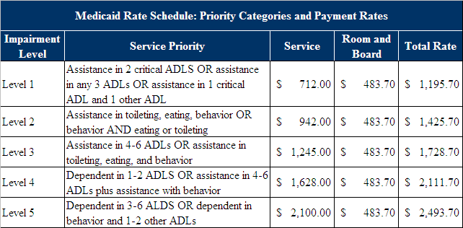

Washington

Scope of Program
In 1996, regulations were issued for licensing boarding homes that contract with Medicaid for residential care services that cover Assisted Living. In September 2004, Washington adopted revisions clarifying that boarding homes are allowed, but not required, to provide assistance with ADLs. However, facilities that do provide assistance with ADLs must address all ADLs defined by the rule and are not allowed to select among ADLs.

Services provided include three meals per day, housekeeping and laundry, assistance with ADLs, medication reminders and administration, activities and recreation, social work services, social and medical transportation, and intermittent licensed nursing services. Medicaid contract standards require that providers ensure that both physical environment and the delivery of Assisted Living, services are executed in a manner that reflects personal and social values of dignity. To contract with Medicaid Assisted Living facilities must provide individual units with a private bathroom and kitchenette, while boarding homes can have shared bathrooms and kitchenettes.

Medicaid Waiver Eligibility Criteria
To be eligible for Assisted Living services, consumers must be age 65 or older and be able to pay the provider the standard Supplemental Security Income (SSI) payment minus a personal needs allowance (2007: $562.22 room and board and $60.78 personal needs allowance).

An individual must have an unmet need, partially met need or the activity did not occur because the clients were unable or no provider was available in at least three or more of the following categories:

- personal hygiene;
- bed mobility;
- transfers;
- eating, toilet use, dressing; or
- locomotion in room, locomotion outside room, and walk in room.

Alternatively, the individual must need extensive assistance with one or more of the following ADLs:

- bed mobility and skin problems;
- transfer;
- toileting, bathing;
- ambulation;
- eating;
- medication management;
- personal hygiene;
- dressing or body care treatment; or
- skin and foot care.

Medicaid Rate Setting Methodology
In 2001 the Aging and Disabilities Administration conducted a time study to determine the nursing staff hours necessary for each level of care.

Activities of daily living score range from 2 to 28 and these include:

- personal hygiene;
- bed mobility and transfers;
- eating, toilet use, dressing; and
- locomotion in room, locomotion outside room, and walk in room.

Each area is given a score from 1 to 4:

- 0 for independent
- 1 for supervision
- 2 for limited assistance
- 3 for extensive assistance
- 4 for total dependence, did not occur because no provider, did not occur because client not able.

The reimbursement rate includes the following components:
- Salary Wages: The 2001 time study has been used to determine the reimbursement rate for staff wages for Assisted Living facilities. A part time figure is also included by dividing the total number of full-time salaried staff by part-time salaried staff.
- Hourly Wages: Calculated using the Office of Employment Statistics (OES) 2007 Median Wage Data for Personal and Home Care Aides.
- Rent: Calculated using the Marshall and Swift Valuation, a leading provider in build cost data.
- Expenses: The expense portion of the reimbursement is based on cost reports submitted by nursing homes. Assisted living facilities are reimbursed at the 25th percentile of the nursing home cost reports. The expense portion of the reimbursement is only rebased when mandated by legislature and includes the following variables:
  - Nursing supplies
  - Total Food
  - Administrative Supplies
  - Travel
  - Telephone
  - Dues and subscriptions
  - Education and In-Service
  - Insurance
  - Advertisement
  - Miscellaneous Taxes
  - Utilities
  - Laundry, Housekeeping and Dietary supplies
  - Equipment Lease Pay, Licenses
  - Maintenance Purchased Services
  - Maintenance Supplies
  - Property Insurance
  - Real Estate Taxes

There is a Capital Add-On rate for Assisted Living Facilities that maintain 60% or more Medicaid Occupancy, which is 7% more than the regular daily rate.

Table 19: King County, Washington Assisted Living Reimbursement Rates
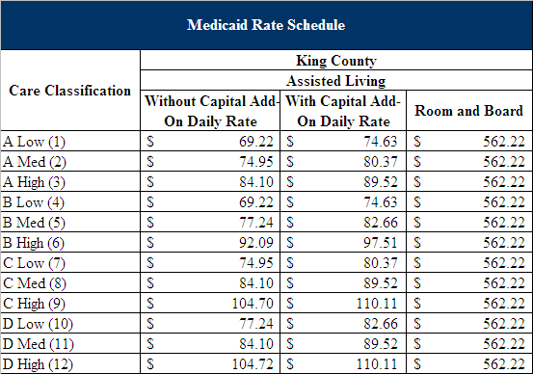

Table 20: Metropolitan Washington Assisted Living Reimbursement Rates
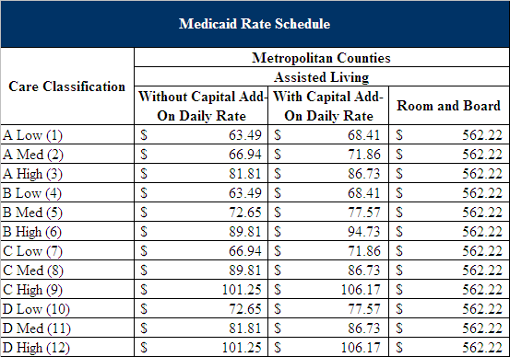
Metropolitan Counties: Benton, Clark, Franklin, Island, Kitsap,
Pierce, Snohomish, Spokane, Thurston, Whatcom and Yakima
Table 21: Non-Metropolitan Washington Assisted Living Reimbursement Rates
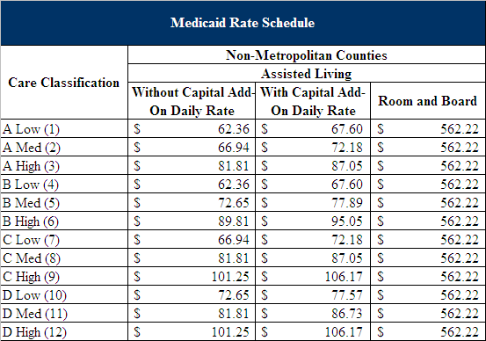
Non-Metropolitan Counties: Adams, Asotin, Chelan, Clallum,
Columbia, Cowlitz, Douglas, Ferry, Kittitas, Garfield, Grant,
Grays Harbor, Jefferson, Klickitat, Lewis, Lincoln, Mason,
Okanogan, Pacific, Pend Oreille, San Juan, Skagit, Skamania,
Stevens, Wahkiakim, Walla and Whitman

Summary
The review of the ODA PASSPORT and Assisted Living system and review of general rate setting alternatives, other Ohio Medicaid program rate methodologies, and peer state Medicaid rate methodologies has enabled PCG to make informed decisions on approaches which are best fit for the Ohio system. For example, these best practice methodologies include use of cost finding and acuity payment measures for Waiver services. This review was instrumental in defining the potential alternatives for ODA. The study of rate methodologies has allowed PCG to validate the strengths of various methodologies as ODA looks to implement changes to the rate system. In the section that follows, included are detailed recommendations for each of the services provided under the PASSPORT and Assisted Living Waivers.

V. PASSPORT WAIVER EVALUATION

A. Description of Waiver Program Administration and Rate Setting

ODA began administering the PASSPORT Waiver in 1984. The PASSPORT Waiver is designed to exclusively serve the Medicaid-eligible population in Ohio which is over sixty years of age. The goals of the program are to provide services in home and community settings to delay or prevent nursing facility placement and preserve the independence of the individual, as well as maintain their ties to family and friends.

The PASSPORT Waiver is funded through Medicaid. ODA receives an appropriation of funds from the State Legislature, which generates federal match. Community providers that wish to participate in the PASSPORT program engage with their local PAA, which is responsible for the day-to-day operations of the PASSPORT program. There are thirteen PAAs throughout the state.

Based on provider claims submitted through the ODA PIMS system, funding flows from ODA to PAAs and then to the provider. The graphic below summarizes the contracting and reimbursement processes.

Figure 1: PASSPORT Reimbursement Stream
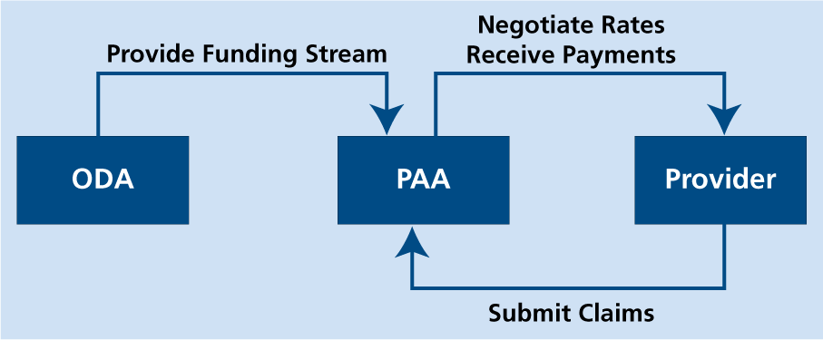

The PASSPORT program currently offers fourteen categories of services:

- Homemaker
- Personal Care
- Adult Day Services and Transportation
- Minor Home Modification
- Transportation
- Non-Medical Transportation
- Home Medical Equipment and Supplies
- Chore
- Social Work and Counseling
- Home Delivered Meals
- Nutritional Consultation
- Independent Living Services
- Community Transition
- Emergency Response System Services

There are four payment methodologies associated with these categories of service: per job bid rates, per item rates, per unit rates, and flat rates.

- Per job bid rate:
  - Minor home modification services
  - Chore services
  - Transportation services
  - Non-medical transportation services
  - Community transition services

- Per item rate:
  - Home medical equipment and supplies

- Unit rate:
  - Adult day services transportation
  - Home delivered meal services
  - Homemaker services
  - Social work counseling services
  - Nutritional consultation services
  - Personal care services
  - Independent living assistance services
  - Emergency response system services

- Flat rate
  - Adult day services

Providers which meet the qualifications to become a PASSPORT provider negotiate per unit, per item, and per bid job payment rates for the provision of services with their PAA. For providers doing business in multiple PAAs, separate contracts must be created between each PAA. Ohio Administrative Code (OAC) 5101:3-31-07 dictates the methodology used by ODA and the PAAs for rate setting purposes.

Data Analysis of Current PASSPORT Program
For the PASSPORT program, PCG first reviewed services over the past three state fiscal years to determine if there have been any significant increases in expenditures or changes in consumer utilization of PASSPORT services. The tables shown on the following pages show that there have not been significant variations from SFY 2006 to SFY 2008 in total expenditures or consumer utilization of services. It is important to consider both the percentage change and the amount of change between years. Oftentimes, the appearance of a large percentage change can be deceiving in that it is based on a small dollar amount change.

Table 22: PASSPORT Expenditures, State Fiscal Years 2006 – 2008
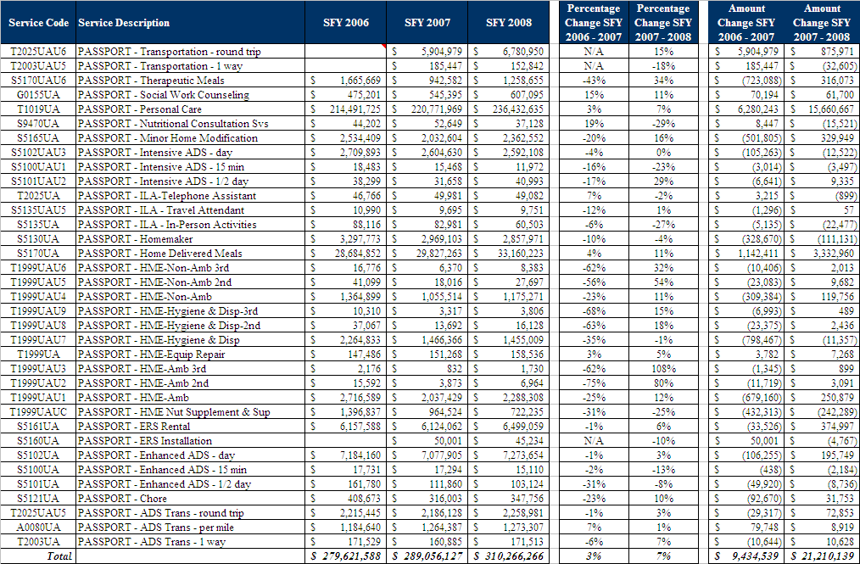

Table 23: PASSPORT Unique Consumers, State Fiscal Years 2006 – 2008
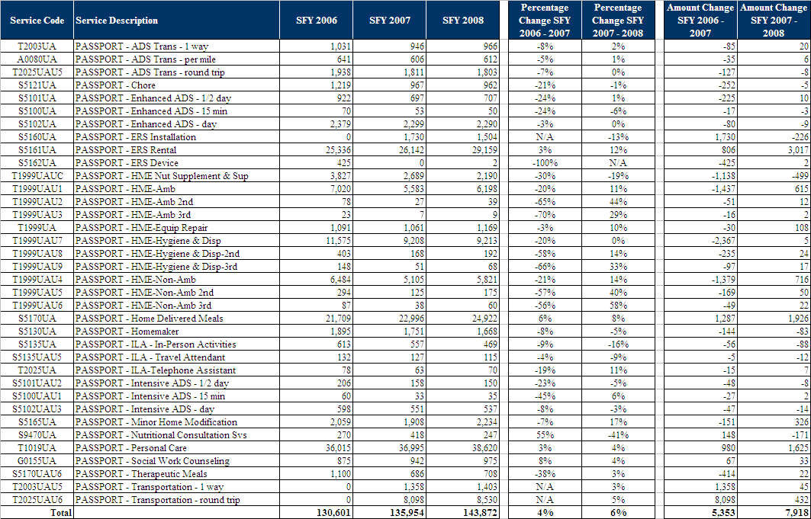
Overall, there have not been any large variations within PASSPORT services over the past three fiscal years; there has been a steady increase in the provision of services. There is no service code outlier that needs to be considered separately from the other service codes.

PASSPORT Analysis by Service
In the section that follows, PCG reviews each PASSPORT service as ranked by state expenditures for each service. Throughout the analysis section, PCG includes a count of providers delivering each service. These numbers are unduplicated provider counts by service type based on data received from ODA on August 28, 2008.

Personal Care Services
As defined in Ohio Administrative Code at (OAC) 173-39-02.11(A), “Personal care is a service designed to enable a consumer to achieve optimal functioning with ADLs [Activities of Daily Living] and IADLs [Instrumental Activities of Daily Living], and includes personal care services and homemaking tasks appropriate to a consumer’s needs. Personal care services must be provided in the consumer’s place of residence.” These personal care activities may include, but are not limited to, household management assistance with self-medication, assistance with ADLs and IADLs, meal preparation, housekeeping, and providing respite services to person taking care of the consumer.

In FY 2008, the largest amount of PASSPORT expenditures on a single service was $236,432,635 for service code T1019UA: Personal Care Services. Approximately 76% of PASSPORT expenditures are spent on this service and about 15.1 million hours of service were provided by 452 providers to 38,620 consumers. The average consumer used about $6,100 of services and received a little less than 400 hours a year of services.

OAC 5101:3-31-07 states that the personal care services rates are one of the services paid for through a “unit rate” approach. Effective July 1, 2008, the Legislature authorized a 3% increase in PASSPORT rates, raising the statewide average from the FY 2007 rate of $4.28 for a fifteen minute unit of personal care service to $4.41 for a fifteen minute unit.

As described previously, CMS commented on this PASSPORT rate setting methodology in their 2003 financial review of the program. CMS requested that the State have a standardized rate setting methodology in place to prevent significant rate variances for the same services across the wavier. In their January 2008 review, CMS reiterated that the state “must have” a uniform rate setting methodology for all PASSPORT Waiver services allowing for regional variations based upon tangible indices.
The 2003 CMS financial review looked at the highest and lowest contract values in order to illustrate significant rate variation for the same service under the Waiver. A different way of looking at the variability is to look at a frequency distribution of contract values. The following table looks at the costs to the state for personal care contracts with an ending date in FY 2008 or later and shows how many and what percent of all contracts are at what rate interval. Roughly speaking, the rates do not clump up at one or two rate intervals. The majority of contracts, approximately 90%, are in the $3.60 to $4.29 range. The number of contract rises as the fifteen minute rate goes up hitting a peak in the $4.10 to $4.19 interval. The average of all contracts for a fifteen minute period of personal care services is $3.97. One way to describe this distribution is to say that about 93% of all contracts are within 10%, $.40 cents (plus or minus), the mean average of the distribution.
Table 24: Number and Percentage of Personal Care Contracts at Different Rate Intervals
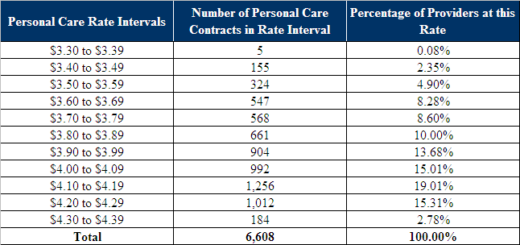
Data Source: Ohio Department of Aging

Figure 2: Number and Percentage of Personal Care Contracts at Different Rate Intervals

Data Source: Ohio Department of Aging
Does the current rate setting method and this resulting variability appear to meet the Social Security Act’s requirements of a rate methodology that promotes efficiency, economy, quality, and access? An argument can be made that it does. For example, the program historically has had tight controls over average cost increases in that there was no increase in the average daily PASSPORT cost between 1992 and 2001. The 2008 CMS review concluded the Waiver was in compliance with quality assurances, and with the exception of rural transportation issues, widespread concerns about consumer access were not made during PCG’s stakeholder meetings.
While this argument can be made, it does not directly answer the persistent CMS concern over the variability in the rates. A 2007 Scripps report discussed the impact of low reimbursement rates at length and spoke to the same concerns that the CMS Regional Office did. Stakeholders also raised the issue of low reimbursement. For example, one stakeholder expressed the view that the rate setting is so economical that there are negative consequences to it in that larger, more established providers are dropping out of the program being replaced by smaller not so well established providers.
Through data analysis, PCG attempted to test the hypotheses related to personal care services and potential access issues. In terms of accessing personal care services, PCG reviewed whether or not PASSPORT eligible consumers were using personal care services in their county. The hypothesis is that high utilization in a county translates into small issues with access.

PCG collected population data by county from the ODJFS website. Such data was broken down by age category and by Medicaid eligibility. Using the number of people in each county over age 64 that are eligible for Medicaid, PCG calculated the percentage of people who are using the personal care service. In no county is the percentage of PASSPORT qualified individuals that are using the personal care service greater than 50%. In only two counties is the percentage of persons using PASSPORT services among the over 64 Medicaid eligible population higher than the percentage of person using nursing facility services.

The regression analysis completed by PCG did not prove “access” is negatively impacted by poverty levels in the county, by the number of providers in the county, or the rate amount. Additionally, providers noted during interviews that access was not an issue for consumers because of the open provider enrollment policy. Although the scope of this study was not intended to identify access and community capacity, the above evidence suggests that ODA rates may be appropriate to attract a sufficient amount of providers. ODA may consider studying access and community capacity as part of future initiatives.

Home Delivered Meals
Home delivered meals, as defined by the Ohio Administrative Code, is a service that provides one to two safe and nutritious meals per day that meet the Recommended Dietary Guidelines (RDA) and Dietary Reference Intakes (DRI).

In FY 2008, the second largest amount of PASSPORT expenditures spent on a single service was $33,160,223 for service code S5170UA: Home Delivered Meals. Approximately 11% of PASSPORT expenditures are spent on this service and 109 providers prepared and delivered about 5.5 million meals to approximately 25,900 consumers. The rate of reimbursement provided by the state per unit in FY 2008 was $5.97. A consumer can receive up to two meals a day; the actual yearly average is about 223 meals per consumer. The average person used about $1,331 of services. This service is a combination of actions, including the preparation of the meal, its packaging for transportation, and its transportation and delivery.
The same unit rate procedures governing the personal care services are also applicable to S5170UA: Home Delivered Meals. The state set maximum rates that it will pay for particular services. State data shows that the unweighted average state maximum rate across the thirteen PASSPORT regions is $6.15. The highest regional rate is $6.62 and the lowest regional rate is $5.73, a 16% difference. State data for differences in regional rates for therapeutic meals shows a 6% difference between the lowest and highest maximum rates.
A related service code, S5170UAU6: Therapeutic Meals is also one of the fourteen PASSPORT service codes that had more than a million dollars paid for it in FY 2008. In FY 2008, $1,258,655 was spent by the state to provide 148,070 therapeutic meals to 708 persons at an average reimbursement rate of $8.50 per meal. There were fifteen unique therapeutic meal providers. Approximately .41% of all PASSPORT expenditures were spent for therapeutic meals. Defined in Ohio Administrative Code at 173-39-02.14(G)(4) “A therapeutic diet must be authorized by a physician or licensed dietitian as part of a treatment of a disease or a clinical condition to eliminate, decrease, or increase certain substances in the diet. It is a food regimen requiring a daily minimum or maximum amount of one or more specific nutrients or a specific distribution of one or more nutrients.”
A different way of looking at variation is look at current contracts that individual providers have. Providers typically serve multiple counties and thus can have a rate for each county. The 109 unique home delivered meal providers collectively have 887 contracts with an ending date of 2008 or later. The data shows that the average provider serves about eight counties. The figure below shows the distribution of the rates in these 887 county contracts. The majority of rates, approximately 80%, are within a $.60 cent spread from $5.70 to $6.29. The mean of the distribution is $5.99. One way to describe this distribution is to say that 80% of all contracts are within 5%, or $.30 cents (plus or minus) the mean of the distribution.
Table 25: Number and Percentage of Home-Delivered Meal Contracts at Different Rate Intervals
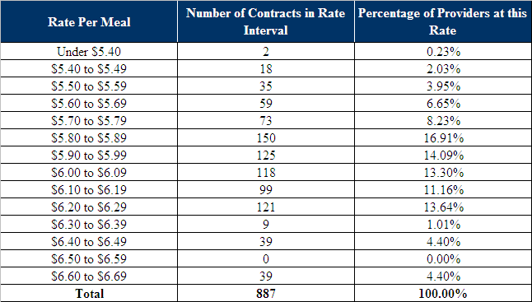

Data Source: Ohio Department of Aging

Figure 3: Number of Home-Delivered Meal Contracts at Different Rate Intervals
Data Source: Ohio Department of Aging

How do these reimbursement rates compare with other Ohio related meal costs? Ohio has two other large meal programs besides PASSPORT. The Administration on Aging has a data collection system, called the National Aging Program Information System (NAPIS), which collects data on the operation of each state’s State Unit on Aging. Ohio NAPIS data for FY 2006 shows the average rate of reimbursement provided by the state of the 2,603,329 meals provided in congregate care settings to 42,242 participants was $5.73. The NAPIS data also report that in FY 2006 the State Unit on Aging paid $36,111,991 for 5,996,363 home delivered meals to 31,387 persons for an average cost of $6.02. The $0.29 cent difference between the cost of a congregate care meal and a home delivered meal seems reasonable in that home delivered meals would cost more than meals provided, for example, to a group of persons in a senior center. The average rate for a meal served in the PASSPORT program in FY 2008 is virtually the same as a home delivered meal served in the State Unit on Aging program. It is important to note that the cost of providing meals for the ODA program are separate and distinct from the cost of providing meals for alternative programs due to the use of volunteer time. ODA staff confirmed that the ODA meal programs do not utilize volunteers. In addition to volunteer time, a 2006 Nutrition Survey by the Department of Aging discusses other differences among home-delivered meal providers. There are differences in the kinds of meals provided, the volume of meals provided and the degree to which providers make their own meals or purchase meals from a food services provider.

There are at least six cost centers involved in home delivered meals: raw material costs, administration, meal preparation, packaging, transportation, and meal delivery. The most frequent comments heard by PCG stakeholder interviews are concerns about the impact of higher transportation costs and higher raw material costs. Persons interviewed report that the recent increases in the costs of these two essential elements has had a negative impact on the willingness of volunteers to contribute to the program where transportation distance is an issue, and has made obtaining raw materials more difficult. These concerns are well founded. The figure below shows that there has been more than a 20% increase in the cost of gasoline in Ohio during the period August 29, 2007 to August 29, 2008

Table 26: Gasoline Prices in Ohio Cities
Gasoline Prices In Ohio
City | August 29, 2007 | August 29, 2008 | % Increase
Akron | $2.96 | $3.61 | 22.09%
Cleveland | $2.95 | $3.62 | 22.71%
Dayton | $2.96 | $3.63 | 22.47%
Cincinnati | $2.98 | $3.65 | 22.62%
Columbus | $2.98 | $3.61 | 21.21%
Toledo | $2.94 | $3.61 | 22.79%

Data Source: http://www.fueleconomy.gov/feg/gasprices/states/OH.shtml
Commodity prices in Ohio have also increased substantially in the last year. For example the CPI for commodities in the Cleveland Akron area increased 8 per cent from July 2007 to July 2008. There could be more food inflation ahead. The Producer Price Index for Intermediate Goods show a 16.2 percent increase over the period July 2007 to July 2008 as of August 29, 2008 data.

Adult Day Services
OAC 173-39-02.1(C)(1) defines enhanced adult day service as including supervision of all ADLs and supervision of medication administration and/or hands-on assistance with one ADL (except bathing), hands-on assistance with medication administration, comprehensive therapeutic activities, and intermittent monitoring of health status.

OAC 173-39-02.1(C)(2) defines intensive adult day service as including all services mentioned in enhanced services above plus assistance with two or more ADLs or bathing. The figure below shows the predominate service is day long adult day services and that there were roughly 3.7 times as many days of enhanced care paid for than days of intensive care.

In term of expenditures, Adult Day Services (ADS) is the third largest PASSPORT service. The nine service codes that comprise it show approximately $14.1 million in FY 2008 expenditures comprising 4.54% of all PASSPORT expenditures. The rate structure consists of three services, enhanced and intensive adult day services and adult day transportation, each with three levels of payment. For the two levels of adult day services, enhanced and intensive, providers are reimbursed flexibly for whatever unit type by which the segment of time is measured, by fifteen minutes, half day, or full day. Transportation has a similar flexibility in its reimbursement: one-way, round trip, or by the mile.

Table 27: Adult Day Services, FY 2008 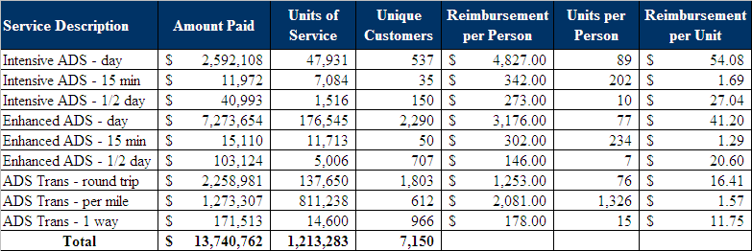
Data Source: Ohio Department of Aging

The table shows that 537 consumers received approximately 89 days, on average, of intensive full day adult day services at an average cost of about $54 per day to the State and 2,290 consumers received approximately 78 days on average of enhanced full day adult day services at an average cost of about $41 per day to the State. About 47 providers billed for intensive day services and 100 providers billed for enhanced day services. The numbers of providers billing for each level of adult day services are not mutually exclusive; that is, there are some providers that bill for both intensive and enhanced adult day services. Over the course of the year, approximately 1,800 consumers had a round-trip transportation claim for day care services.

Transportation
OAC 173-39-02.13(A) defines transportation as “a service designed to enable a consumer to gain access to medical appointments specified by the consumer’s plan of care, when medical transportation is not otherwise available or funded by state plan Medicaid or any other source.” Both the round trip and the one-way trip are negotiated rates. There is no methodology for setting the rate. However, the rates are capped by Appendix A of OAC 5101:3-1-06.1 which sets a limit of $1,326.13 for a round trip and $633.06 for a one-way trip.

In FY 2008, the fourth highest amount of expenditures spent on a single service was $6,780,950 for service code T2025UAU6: Transportation – round trip. Approximately 2.2% of PASSPORT expenditures are spent on this service and about 94,300 round trips were provided to 8,530 consumers. The average round trip cost to the State was $71.91. Service code T2003UAU5: Transportation – one-way trip has the 20th highest amount of expenditures incurred in the PASSPORT program with $152,842 expended, reflecting .05% of all PASSPORT expenditures. About 4,594 one-way rides were provided to 1,403 consumers at an average cost of $33.27 per ride.

Counting both the number of Adult Day Services transportation providers and non-ADS providers, there are 193 unique transportation providers.

Emergency Response Systems (ERS)
Emergency Response Service, as defined in the Ohio Administrative Code, includes the Emergency Response service, the ERS device, and the ERS installation. The ERS equipment is a two-way communication system that allows the consumer to alarm an emergency response center which can intervene in an emergency.

In FY 2008, the fifth largest amount of PASSPORT expenditures spent on a single service was $6,499,059 for service code S5161UA: Emergency Response System (ERS) Rental Approximately 2.09% of PASSPORT expenditures are spent on the monthly rental fee, excluding installation and testing. This service was delivered by 69 providers and to approximately 29,159 consumers. In 2008, PASSPORT paid for 239,692 months or 19,974 years of service. The average consumer received the service for 8.22 months of service during the year. The majority of consumers use the ERS service on an ongoing basis. The number of consumers using this service, 29,159, is 75% of the number of consumers receiving personal care, 38,620. National utilization data on specific Waiver services is not reported on by CMS, so it is difficult to compare a 75% utilization rate for this service to the utilization experience of other states.

Service code S5160UA pays for ERS installations and 1,515 uses of it were made during FY 2008 at an average reimbursement rate of $30.08 per installation and a total state expenditure cost of $45,234. Regional average rates for monthly ERS rental contracts were all at $32.26 as was the state wide average. Detailed data on each specific contract was not available.

Regional average rates for monthly ERS installations were all at $31.83, as was the state wide average. However actual contract values were highly skewed towards amounts just below the $31.83 cap. PCG reviewed the 2,180 contract values with an ending date of 2008 or later in the database of installation contract values provided by the State. About 15% had a zero value attached to them, 36% of all contracts were below $30, and the other 64% were $30.00 and higher. In other words, two-thirds of all installations were billed just below the state and regional cap of $31.83. Because of the large number of installation contracts with a zero cost, the average was $24.92. The fact that some contracts have a zero installation cost is not unusual in discussions of ERS. It may be the case that some providers market the service by doing free installations to obtain the resulting monthly rental fees.

How do the PASSPORT rates for monthly rental and installations of emergency response systems compare to national prices? One publication states that national prices for the monthly cost of ERS services currently range from $28.95 to $35.00. A 2006 study of assistive technology found that 124 state Waivers of the 202 reviewed covered ERS services. PCG is not aware of a national study that has reported data on the installation cost of ERSs paid for by these Waivers. However, $31.83 seems to be a reasonable amount to pay given that there are other states that pay the same or more: Virginia ($50.00), Louisiana ($30.00), Florida ($95.00), New Mexico ($1.00 to $133.96), South Carolina ($35.00) and Wyoming ($70.00).

Homemaker Services
OAC 173-39-02.8(C) defines homemaker services as including, but are not limited to, assistance with meal planning, meal preparation, grocery purchase planning, assisting consumers with shopping and other errands, laundry, including folding, ironing, and putting away laundry, and house cleaning.

In FY 2008, the sixth largest amount of PASSPORT expenditures spent on a single service was $2,857,971 for service code S5130UA: Homemaker. Approximately .92% of PASSPORT expenditures are spent on this service and 232 providers provided homemaker services to approximately 1,668 consumers. S5130UA is a 15-minute billing code and the average reimbursement rate was $3.47. In FY 2008, PASSPORT paid for approximately 205,727 hours of homemaker service.

Regional caps run from $3.42 to $3.72 with a statewide cap of $3.58. The figure below shows the frequency distribution of homemaker rates in contracts with an ending date of 2008 or later. Across all 6,478 rates in the database the average is $3.51. Approximately 10% are between $3.20 and $3.29 another approximately 10% are between $3.30 and $3.39 and the rest are between $3.40 and $3.70. Roughly 88% of the rates are within 6%, $.20 cents, of the mean of the distribution. In other words, 88% of the contract values are between $3.30 and $3.70. There are very small numbers of outliers at both the bottom and top of the distribution.

Table 28: Number and Percentage of Homemaker Contracts at Different Rate Intervals
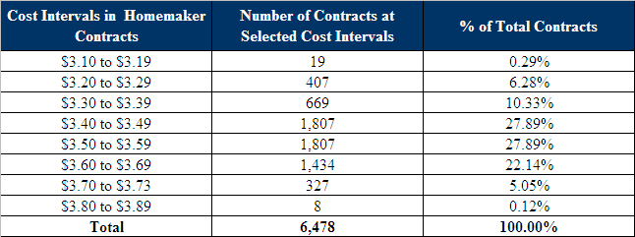

Data Source: Ohio Department of Aging

Figure 4: Number and Percentage of Homemaker Contracts at Different Rate Intervals

Data Source: Ohio Department of Aging

Minor Home Modifications
OAC 173-39-02.9 (A) defines minor home modification as modification, maintenance, and repair. These are services provide environmental accessibility adaptations to the structural elements of the interior or exterior of a consumer’s place of residence that enable the consumer to function with greater independence in the home and remain in the community. Excluded from this service are those adaptations or improvements to the home that are of general utility and not of direct medical or remedial benefit to the consumer, such as carpeting, roof replacement, central air conditioning, and adaptations which add to the total square footage of the home.

In FY 2008, the eighth largest amount of PASSPORT expenditures spent on a single service was $2,362,552 for service code S5165UA: Minor Home Modification. Approximately .76% of PASSPORT expenditures are spent on this service and 69 providers provided minor home modification services to approximately 2,200 consumers. In FY 2008 PASSPORT paid for approximately 2,868 minor home modifications. The average modification cost $824.

Home Medical Equipment
Home Medical Equipment, as defined by in OAC, is designed to promote in-home safe health care through the provision of equipment and supplies. Allowable purchases include items which allow the consumer to function with greater independence and prevent placement into a nursing facility. Examples of home medical equipment are, but not limited to, walker baskets or trays, room monitors, eating and dressing assistive devices, medication dispensers, incontinent bath wipes, and room monitors.

In FY 2008, the ninth largest amount of PASSPORT expenditures spent on a single service was $2,288,308 for service code T1999UAU1: Home Medical Equipment Ambulatory. Approximately .74% of PASSPORT expenditures are spent on this service.
OAC 173-39-02.7(A) broadly states that home medical equipment and supplies are “…items and/or supplies eligible to be purchased, installed and/or rented …that enable the consumer to function with greater independence in the home and help prevent the consumer’s placement in a nursing facility.”

While T1999UAU1 is the largest service code in term of expenditures it makes more sense to discuss all home medical equipment codes as a group. Eleven of the 36 service codes comprising the PASSPORT services are related to home medical equipment. The Figure below shows that the combined expenditures for these eleven codes totals $5.864M and accounts for 1.89% of total PASSPORT expenditures. Approximately 77,285 units were billed at an average cost of approximately $76 per unit. The code with the highest number of units, 37,674 is HME Hygiene and Disposables. Given the unit cost of $38.78, these may be largely continence supplies. The only other service code whose units are determinable is T1999UAUC: Nutritional Supplements.

Table 29: Home Medical Equipment and Supplies, FY 2008
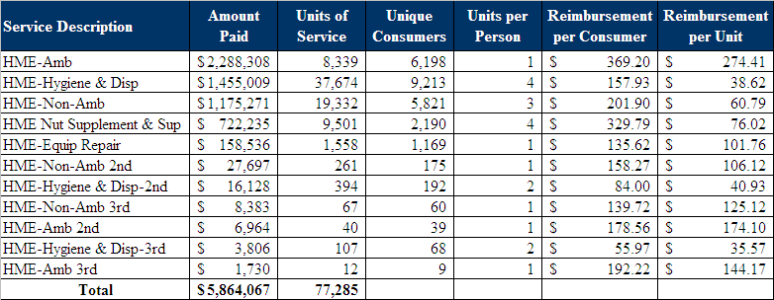

Data Source: Ohio Department of Aging

There are 134 unique providers across all categories of home medical equipment. The data shows that these 77,000 purchases are spread across numerous consumers. PCG did not have individual level data so unduplicated consumers across all eleven service codes could not be determined. The pattern is that each consumer uses a little bit of every service as distinct from a pattern where a small number of consumers use a large number of services or a large number of consumers use a few services.

Remaining Service Codes
The discussion above has considered all but six of the 36 service codes comprising PASSPORT. The largest of them are social work counseling which is provided by 58 providers and chore service which are provided by 69 providers. The remaining six codes are shown below. Their collective expenditures account for about one third of one percent of total PASSPORT expenditures.

Table 30: Remaining Service Codes Not Previously Discussed
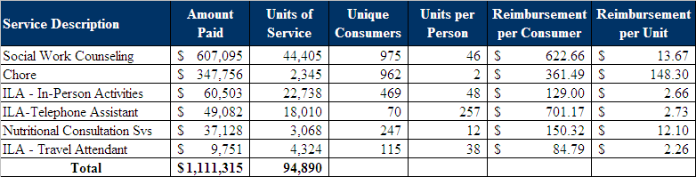

Data Source: Ohio Department of Aging

B. Strengths and Weaknesses Analysis

The PASSPORT program has operated in Ohio for more than twenty years. During this time, the program has provided qualified consumers with a variety of options for receiving services in their homes and communities. The program is very popular among consumers needing supports and has been highly regarded by members of the State Legislature.

The following table represents a summary of the PASSPORT Waiver Program strengths and weaknesses analyses. All data is arranged according to the key measures defined in Section III of this report.

PASSPORT WAIVER PROGRAM
Measure | Issues Noted
Fairness | - Strength: Current rates appear to be fair as evidenced by the ability to attract an adequate supply of service providers in most areas of the state.  - Weakness: Some areas of the state, particularly rural areas have difficulty maintaining a sufficient number of providers to meet the demand for services.  - Weakness: The absence of a rate setting methodology that includes predictable rate increases to reflect changes in the cost of providing services is problematic.  - Weakness: Current rate setting methodologies do not include a mechanism for adjusting rates in the event of unusual increases in costs, such as recent increases in the cost of gasoline.  - Weakness: Providers are not paid for services when they make a good faith effort to deliver services and the service recipient is not available or chooses not to receive services.  - Weakness: For some PASSPORT services, the payment rate is less than the rate paid by ODJFS and county levy programs for comparable services.  - Weakness: The payment rates for services make it increasingly difficult to attract and retain qualified staff.
Quality | - Strength: Current rates allow for the provision of services at a level of quality that is generally acceptable.  - Weakness: The current rate setting methodologies do not incorporate quality/outcome based considerations.  - Weakness: The payment rate for services makes it increasingly difficult to attract and retain qualified staff and is exacerbated by staff moving from provider to provider based on pay rate, thereby affecting the quality of services.  - Weakness: Reimbursement rates are affecting the way some services, like home delivered meals, are being provided.
Efficiency | - Strength: Overall, people who receive PASSPORT services are pleased with the availability and timeliness of services.  - Strength: The benefits received by service recipients are in line with the intended outcomes.  - Strength: The cost of services is considered reasonable.  - Strength: Computerization of billing systems has increased the efficiency of service delivery.  - Weakness: Service recipients are not held accountable when they fail to notify providers in advance that they do not want services or when services are refused at the point of delivery.  - Weakness: Efficiency in service delivery could be increased by improved coordination of service delivery to people living in nearby areas.
Acceptability | - Strength: Current rates are sufficient to attract an adequate supply of service providers in most areas of the state.  - Strength: Current rates are well known and well understood by providers.  - Strength: Regional rate structures provide the PAAs with greater flexibility in securing services at the best price for the best quality.  - Weakness: Some areas of the state, particularly rural areas have difficulty maintaining a sufficient number of providers to meet the demand for services.
Resource Based | - Strength: Most rates do account for differences in the level of care needed.  - Weakness: Personal care rates do not take into account the cost of delivering services to individuals with special needs.  - Weakness: Rates do not reflect the cost of interpreters when service recipients do not speak English.
Simplicity | - Strength: The current rates are known to providers.  - Strength: The existing administrative requirements associated with the current rate structure are reasonable for both administering agencies and providers.  - Weakness: The basis for current rates is not understood, thereby leading to a lack of transparency.  - Weakness: The methodology for reimbursing transportation services is not clear. Transportation services can be provided on a per unit, per mile, per trip, and per round trip.  - Weakness: The current rate setting structures are not tied to the actual cost of delivering services.  - Weakness: A lack of uniformity of the interpretation of regulations creates a greater administrative burden for providers.  - Weakness: Rates for some services, particularly personal care, vary from county to county and vary depending upon the payor creating administrative inefficiencies.
Outlier Recognition | - Strength: The current structure has some allowance for the personalization of services at the client level.  - Weakness: The rate setting structures do not account for the additional costs associated with providing services in rural and some urban areas.  - Weakness: The current structure does not support the needs of certain special needs clients.
Compliance | - Strength: The current rate setting methodologies are consistent with state laws and regulations.  - Weakness: CMS has raised questions regarding the rate setting approaches used for some PASSPORT services, particularly personal care.  - Weakness: Inconsistent regional interpretations of PASSPORT regulations.
Other applicable comments | - Stakeholders feel that the rate setting methodologies have not evolved to incorporate current operational costs and current technology.  - AAAs should have the ability to sanction PASSPORT service providers if a violation occurs, in addition to ODA’s ability to sanction providers.

The following are more detailed descriptions of some key points noted in the previous table.

Strengths of PASSPORT Waiver Program

Regional average rates add flexibility to PASSPORT system.
The regional average rates and the ability to negotiate rates between PAAs and providers allows for regional variations in cost to be taken into account for the PASSPORT program reimbursement methodology. Regions in Ohio vary according to cost of living and average income. These differences are also recognized in ODMRDD Waiver reimbursement and the three regional peer groups used in nursing facility reimbursement methodology. The current PASSPORT rate setting methodology takes into consideration regional differences by allowing for different regions to charge different prices for the same services. The PASSPORT program has been using regional average rates since July of 1995. The regional rates theoretically reflect the regional economy and market value for the area.

ODA utilization system allows for ease in PASSPORT administration.
The PIMS system that ODA uses to manage the PASSPORT program is quite robust, making the system a strength of the PASSPORT program. PIMS was phased in over a two-year period and as of September 2004 was statewide. PIMS is a claim adjudication system which manages both consumer and provider information. Medicaid Waiver eligible PASSPORT claims are processed through PIMS.

Data from the PIMS system allows ODA to administer and monitor the PASSPORT program, its providers, and the provision of PASSPORT services. For example, the PIMS system allows for ODA to compare the number of services approved for a consumer to the number of hours of service actually provided to a consumer. This comparison can assist ODA in making determinations about the quality of providers.

Weaknesses of PASSPORT Waiver Program Rate Setting Methodology

CMS has concerns about rate setting methodology.
As described earlier in this report, CMS has raised concerns about the rate setting methodology used for some PASSPORT services, particularly personal care. This concern was the impetus for the current study of PASSPORT rate setting methodologies.

There is a lack of rate transparency in the PASSPORT program.
Many providers do not understand the basis for existing rate setting methodologies, including how ODA calculates the average rate and ceiling rate of payment. OAC establishes a regional rate for each service determined by “the weighted average rate paid in the region using cost and unit data either from the most recently completed state fiscal year or the most recent twelve calendar months for which complete data is available, whichever is later;…” This process just develops a ceiling up to which rates can be negotiated. The actual contracting of each service with each provider is dependence on factors such as history, utilization, and other subjective measures which may not be the best indicators or quality and/or efficiency.

Rate setting is not based on the actual cost of providing services.
ODA does not currently require providers to submit cost reports reflecting the actual costs associated with the provision of services. The fact that cost reports do not exist has an impact on the role of actual service delivery costs in the rate methodology process. The average rates and ceiling rates are set by ODA without knowledge of the costs of providing services. It is possible that the target rates set by ODA could be too high for a type of service, meaning providers are benefiting financially through contracting to provide a type of service, or the target rates set by ODA could be too low, meaning providers are losing money providing the type of service because their reimbursement is lower than their costs. The latter could impact consumer access to services and provider quality if there are not enough qualified providers willing to provide the type of service.

Stakeholders felt that the rate setting methodology has not evolved to incorporate the current operational costs. Stakeholders would like to implement a regular system to review rates so that they incorporate variations in operational costs.

Program administrative costs are high.
There are high administrative costs associated with the management of the different rates which exist in the PASSPORT program. Both PAAs and providers spend lot of time managing different rates, both through hard copies of contracts and in their billing systems. Especially in the cases where a provider is working in more than one PAA region, it is burdensome and arduous for providers to keep track of which rates are active for which regions for which consumers. PAAs have said that this puts more pressure on them to provide the administrative support necessary to keep their providers in the program. Again, access and provider quality could be in jeopardy if providers are not able to manage the administrative processes required to be a PASSPORT provider.

Reimbursement rates are changing program and service definitions.
Some stakeholders indicated that (perceived) low rates of reimbursement for certain PASSPORT services have changed some of the program and service definitions. For example, meals are an area of concern with respect to low reimbursement rates. Adequate rates of reimbursement for meal service would allow providers to deliver hot meals in person to consumers a few times per week. Given the recent increase in food supplies and gas, meal providers may now only be delivering a full week’s worth of frozen meals once per week. Many times there is no interaction with the consumer. This has an impact on the quality of food and life of consumers, since meal delivery was an opportunity for them to interact with other people on a regular basis. This is just one example of how rates change provider behavior ad ability to service consumers effectively.

Currently, rates do not include quality incentives.
Once a rate has been negotiated to provide a type of service, a provider is paid that rate regardless of the quality or non-quality aspects of their service provision. PCG has seen incentive systems developed in other states which can impact the quality of service being provided. For instance, a state could choose to reimburse a provider only 90% of the rate for that particular service and, depending on established quality measures, a provider could receive reimbursement up to the full rate amount at the end of the year. Quality based payment systems are new and still being tested and vetted among different reimbursement systems.

PASSPORT transportation service rates and types are disparate.
The methodology for reimbursing transportation services is not clear. Transportation services can be provided on a per unit, per mile, per trip, and per round trip basis. It is not clear to providers what the best way to charge for the service is. Depending on the length of the trip, it may be more cost effective for the provider to charge by mile while for other trips, just on a rate for the trip. It is not easy for providers to determine the best rate to negotiate, which can create issues for access. If providers do not know how to best provide the transportation service in a cost-effective manner, then they may not be willing to contract to provide the service.

The current structure does not recognize the needs of certain special needs clients.
Clients are sometimes located in rural or urban areas or have special needs that affect the cost of service delivery. Consequently, PASSPORT providers sometimes are faced with the challenge of providing services to these clients due to the cost. The high costs of providing services to these clients arise from increased transportation costs and/or the difficulty in securing a staff member to deliver the services necessary. An increase in rates for special needs clients would allow for providers to supplement the cost and incentivize staff to provide needed services. Additionally, it is difficult to secure providers who will provide specialty services, such as nutritional counseling.

C. Rate Setting Recommendations

No single rate setting approach is appropriate for all of PASSPORT’s component rates. Rather each rate needs to be examined separately. Such a review needs to encompass the:

- Rationale setting the amount of payment;
- Use of inflation factors, rebasing, and other rate setting actions influencing the rate;
- Current expenditures incurred by the state for the service;
- Amount paid for the service;
- Number of consumers provided the service;
- Number of services provided; and
- Number of providers providing services.

PCG believes that rate setting is more than defining a commercial transaction. A good rate setting process strengthens a program’s policies, encourages provider participation, and helps ensure that consumers get the services they need. PCG’s rate setting perspective emphasizes:
- Provider and consumer participation in the rate setting;
- Methodologies that are reasonable and consistently applied;
- Methodologies that are grounded in facts and data not opinions and anecdotes;
- Methodologies that recognize the variability of providers including their size, mission, geographical location, and mix of services provided;
- Successfully implementing a rate setting process that is straightforward to administer and does not encumber the agency with needless appeals or cumbersome administrative tasks; and
- Putting in place a rate setting process that does not create unnecessary reporting and administrative burden on providers so that they can concentrate on their services and consumers they help.

PASSPORT: Personal Care Services

PCG recommends a cost-based weighted regional rate for personal care services.
PCG recommends that ODA establish a Personal Care Service rate setting approach which is grounded in a regionally based rate for 15 minutes of service. The proposed model would “front end” or “load” the first hour(s) of service at a higher rate and discount rates for Personal Care Services of longer duration. A cost survey of providers would be used to identify a base rate. Then that rate would be adjusted according to the duration of service provided. ODA could conduct a study to determine how to “load” the base rate or could utilize the ratios and methods used by ODJFS for the Home Care Waiver, Home Care (State Plan), and Transitions Waiver. These programs pay a base rate (one hour) and subsequent 15 minute unit rates that are approximately 50% of the base rate. Because of the differences in staffing and service complexity PCG would recommend that ODA develop an independent analysis to determine the most appropriate method.

Of course, this model is dependent on 3 major decisions; 1) cost finding methods are developed to identify base “per 15 minute” rates for Personal Care Services and 2) how to “load” rates based on time for factors such as travel, and 3) ensure county/regional rates remain a tenant of the Personal Care Service rate methodology. PCG believes this methodology will address CMS’s desire that ODA have a standardized rate setting methodology in place to prevent significant rate variances for the same services across the Waiver and have a uniform rate setting methodology for all PASSPORT Waiver services allowing for regional variations based upon tangible indices.

ODA’s goal is to make payments a fair and reasonable amount for the scope and duration of the service. PCG’s recommendation for Personal Care Services would rebase the rate grounding it in current costs, create a methodology that incorporates greater cost recognition in the first hour, and provide services in a more economical manner since there is more control over higher rates. This methodology will certainly need to address administrative implementation issues including but not limited to cost reporting, technology, education and training, human resources, and other ODA administrative actions.

Personal Care
Service Description | Personal Care
Recommended Rate Setting Methodology | Rebase provider costs using a cost survey, apply regional cost variation, and use a base rate for first hour then 15-minute increments.
Method | Cost-Based
Additional Considerations | County-level variation or peer groups to be established either through cost study results or use of OJDFS occupational wage estimates.
Strengths and Weaknesses | Rebasing is necessary to update costs. Prospective system with regional rates or peer groups and cost limits will recognize provider variations, and provide explanation of rate variability.
Compliance with CMS Audit Concerns | Yes
Peer State Methodologies | Indiana: Unit (Statewide)  West Virginia: Unit (Statewide)

PASSPORT: Home-Delivered Meals

PCG recommends regional or statewide rates based on modest cost survey.
PCG recommends that ODA develop regional or statewide rates based on a modest provider cost survey of only food and transportation costs. Unlike the personal care services recommendation, the purpose of this survey is to collect data on two cost centers and determine what percentage of all costs are attributable to the cost centers of raw materials and transportation and then study if an add-on should be made to cover the exceptional inflationary increases being experienced, and if so, at what level should these cost centers be adjusted. In other words, the recommended methodology is to study the addition of an inflation add-on to those components of the rate that are increasing beyond ordinary expectations, rather than make an adjustment to the rate as a whole.

A second approach to rate setting for home delivered meals that the state may wish to consider is the comparison of rate setting in the three meal programs. In FY 2006, the state paid for 13.7 million meals in its three meal programs: PASSPORT home-delivered meals, the Older Americans Act congregate meal program, and the Older Americans Act home delivered meals. Interviews with state nutrition staff indicate that the meal services providers substantially overlap across the programs and the administrative entities that administer the programs. The cost study will define the specific cost differences between the programs.

While important to obtain efficient compensation, a study of rate components in the PASSPORT program is only one facet of a rate methodology study of home delivered meals. In FY 2006, these three meal programs served approximately 143,000 persons at a cost of $77.2 million. Given their combined size and common administration, it may be possible to obtain lower administrative costs and rate simplification if all three meal programs were studied at the same time. The possible outcome of such a study would be the development of a common rate methodology for all three programs and some consolidation of administration.

Home Delivered Meals
Service Description | Home Delivered Meals  Therapeutic Meals
Recommended Rate Setting Methodology | Regional or statewide rates based on modest cost study of raw material and transportation costs of nutrition providers.
Method | Negotiated bid
Additional Considerations | Consider inflation add on if raw material or transportation costs exceed certain limits.
Strengths and Weaknesses | Meal purchasing is frequently done by competitive bidding. Current system produces consistent negotiations in that 80% of contract values are within 5% of mean average.
Compliance with CMS Audit Concerns | Yes
Peer State Methodologies | Indiana: Unit (Statewide)

PASSPORT: Adult Day Services

PCG recommends that ODA maintain flat statewide rates and build acuity payment.
The rationale for the difference between the enhanced and intensive level is the greater acuity of the consumer. Given this rationale, the state might consider linking the payment of adult day services to an acuity measure of the person receiving the services. All persons receiving PASSPORT services are assessed and information from that assessment could be linked to adult day services rate schedules. For example, it may be possible to use items from the Comprehensive Assessment/Referral Evaluation (CARE) tool or the Acuity Assessment Instrument developed for the MRDD program. A $12 dollar a day difference for taking care of one ADL more is reasonable, but if a person has 2 or more additional ADLs, as required by the intensive level, then $12 is less reasonably linked to acuity and compensation for the additional staff time required.

ADS transportation is a different service and PCG would recommend not “bundling” it with an acuity-based service. Usually ADS providers provide the transportation to and from the program and are not general providers of transportation for persons who do not use the program. PCG is reluctant to include this provider group with transportation providers generally without a better understanding of their cost and revenue structures.

Rate setting for similar services across programs needs to be consistent. To the extent that Assisted Living is tiered by acuity, then acuity concepts in adult day services should be checked for consistency. Both ADS and Assisted Living use daily rates and need adjustments for acuity unlike Personal Care Services whose hours are set by the care plan and are presumed to vary based on the individual’s needs.

Adult Day Services
Service Description | Intensive ADS - 1/2 day  Intensive - ADS 15 min  Intensive ADS - day  Enhanced ADS - 1/2 day  Enhanced - ADS 15 min  Enhanced ADS - day  ADS Trans - 1 way  ADS Trans - per mile  ADS Trans - round trip
Recommended Rate Setting Methodology | Maintain flat statewide rate and develop an acuity-based payment method.
Method | Acuity-Based
Additional Considerations | Can also use county-level adjustment after acuity levels are determined
Strengths and Weaknesses | CMS encourages rates based on the characteristics of individuals served.
Compliance with CMS Audit Concerns | Yes
Peer State Methodologies | Indiana: Unit (Statewide)  West Virginia: Unit (Statewide)

PASSPORT: Transportation
PCG recommends regional or statewide rates based on a review of transportation as part of a comprehensive transportation analysis.
ODA needs to develop uniform regional or statewide rates for transportation services. Another clear recommendation stemming from this look at adult day services is that the transportation component of the adult day services program should be reviewed. Variability by itself is not necessarily a problem. Observed variability might reflect rural and urban differences that local contract setting practices have taken into account. Rather, the process by which adult day service transportation rates are set should be made transparent through a review of them.

Transportation services are provided under the ODA Waiver utilizing 3 separate methodologies; per round trip, pre one-way trip, and per mile. The current methodology defines transportation services as “a service designed to enable a consumer to gain access to medical appointments specified by the consumer’s plan of care, when medical transportation is not otherwise available or funded by state plan Medicaid or any other source.”

PCG recommends that ODA pursue a cost study to better inform the rate setting process. The study goal would be to define the rate variability, number of providers, and negotiation practices within the system (to name a few). A recommendation that may come out of this study is the development of a base rate which can be adjusted for differences in wages, geography, and location of clients.

Transportation is provided in multiple state programs by many of the same providers. While the various rate methodologies are meant to reimburse providers for the differences in wages, geography, and location of clients, there may be opportunities to consolidate methodologies and improve administrative process for contracting. For example, the non-medical transportation rates calculated for the MRDD Waiver seem to be a reasonable methodology. The possible outcome of such a study would be the development of a common rate methodology for state programs.

Transportation
Service Description | Transportation - round trip Transportation - 1 way
Recommended Rate Setting Methodology | Regional or statewide rates based on a cost survey of providers.
Method | Cost-based
Additional Considerations | Cost data would permit a statewide base with county-level variations.
Strengths and Weaknesses | Current system has large unexplained variations in negotiated bids.
Compliance with CMS Audit Concerns | Yes
Peer State Methodologies | Indiana: Unit (Statewide)  West Virginia: Unit (Statewide)

PASSPORT: Emergency Response Systems

PCG recommends maintaining flat statewide rates.
PCG makes no recommendations regarding rate setting for the monthly costs of an ERS service and ERS installation cost. The current monthly rental has no variation in the regional or statewide allowable rates. Both rental and installation rates are in-line with other state Medicaid program reimbursement. The outstanding issue is the utilization rate of the program not the rates that are paid.

Emergency Response Systems
Service Description | ERS Installation  ERS Rental  ERS Device
Recommended Rate Setting Methodology | Maintain flat statewide rates
Method | Unit Rate for rental
Additional Considerations | Rates are consistent with ODJFS Waiver programs.
Strengths and Weaknesses | In current system, two-thirds of installation providers bill close to unit rate, but many have no rate listed and may possibly offer free installation to obtain ongoing monthly fees. Current fees paid are reasonable given what other states pay.
Compliance with CMS Audit Concerns | Yes
Peer State Methodologies | Indiana: Unit (Statewide)

PASSPORT: Homemaker Services

PCG recommends a flat statewide rate
PCG’s perspective for rate setting procedures regarding homemaker services are tempered by the fact that less than 1% of PASSPORT expenditures are used to provide this service and that contract values are clustered closely around the average contract value. Considering other options for rate work, it may not be as useful to study homemaker rates at length. Should the state decide that additional rate development is desired, then a low cost, useful option would be a flat rate based on dividing total expenditures by hours of service provided. The rationale is that the current variation in rates is unexplained and the services provided do not require specialized labor or material costs. If the state thinks variations across regions are an issue, then an Ohio specific regional variation could be based in on Standard Occupational Classification (SOC) data since persons providing homemaker services are classified within 39-9021 Personal and Home Care Aides.

An alternative and reasonable methodology, taking somewhat more time and research to implement, would be to study what other states do and use data from other states or national data to set homemaker services at a percentage of personal care service rates.

Homemaker
Service Description | Homemaker
Recommended Rate Setting Methodology | ODA could consider a flat statewide rate that is calculated by dividing the total budget for Homemaker services by the number of units of services provided.
Method | Flat Statewide Rate
Additional Considerations | Could have budget neutral county-level adjustment. When worked on, consider comparative study of other states, or use percentage of personal care or home health agency rate. In terms of priority this is a minor rate and should be worked on after personal care, nutrition, adult day, and transportation.
Strengths and Weaknesses | N/A
Compliance with CMS Audit Concerns | Yes
Peer State Methodologies | Indiana: Unit (Statewide)  West Virginia: Unit (Statewide)

PASSPORT: Minor Home Modifications

PCG recommends maintaining per job rates
The state has options for improving the rate setting methodology used with minor home modifications. One option is to leave it alone. The reasons for this course of action are that the amount of expenditures is three quarters of one percent of total program expenditures, the amounts paid are negotiated per job through bids, there is no standard unit of service provided, and other states usually reimburse minor home modifications the way Ohio currently does.

However, should the state wish to examine the rate setting methodology further there are two actions it could take. First, it could do a review of how other Waivers handle home modifications. The purpose of the study would be to study the utilization rate and average cost of other Waivers as well as any maximum cost used to cap expenditures for this service. A second action the state could take to review its rate setting procedures for home modifications would be to collect information on the 2,868 home modifications done.

Minor Home Modifications
Service Description | Minor Home Modification
Recommended Rate Setting Methodology | Maintain per job rates
Method | Job
Additional Considerations | Having an atypical service such as home modification services as a per bid service is consistent with the per bid policies of other CMS approved HCBS Waiver programs, including California, South Carolina, and Indiana.
Strengths and Weaknesses | N/A
Compliance with CMS Audit Concerns | Yes
Peer State Methodologies | Indiana: Unit (Statewide)

PASSPORT: Home Medical Equipment

PCG recommends a per item fee schedule
These codes were not included in the 2003 CMS financial review of the program and their variability is not at issue. Ohio already has a methodology for reimbursing home medical equipment. It seems reasonable to use the same reimbursement and billing procedures. In order to maintain flexibility, ODA may wish to establish its own list for selected items that it does think are appropriately priced for the consumers it serves or reserve a negotiated bidding process for selected items at its discretion.

Home Medical Equipment
Service Description | HME-Amb  HME-Hygiene & Disp  HME-Non-Amb  HME Nut Supplement & Sup  HME-Equip Repair  HME-Non-Amb 2nd  HME-Hygiene & Disp-2nd  HME-Non-Amb 3rd  HME-Amb 2nd  HME-Hygiene & Disp-3rd  HME-Amb 3rd
Recommended Rate Setting Methodology | Use ODJFS Medicaid Fee Schedule with negotiated bidding alternative.
Method | Price Based
Additional Considerations | OJDFS has moved towards value purchasing.
Strengths and Weaknesses | Reliance on single price list makes HME reimbursement transparent. It is a fair and efficient reimbursement. Such a list is already in use by Medicaid. In November 2007 CMS approved Ohio Medicaid's request for selective purchasing, "value purchasing", so this method should be acceptable to CMS also.
Compliance with CMS Audit Concerns | Yes
Peer State Methodologies | Indiana: Per item  West Virginia: Per item Medical Equipment

PASSPORT – Social Work Counseling

PCG recommends a flat statewide rate
The collective expenditures of these services account for less than one third of one percent of total PASSPORT expenditures. PCG recognizes that these services are important to the providers who provide them and the consumers who receive them, however, administratively it is not reasonable spend substantial time adjusting rates, outside of wholesale improvements to PASSPORT rate methodologies (cost reporting, inflation adjustments, etc…). Given that variability of rates is an issue then a straightforward methodology would be to use a flat rate approach in which the rate would be set by dividing expenditures by units of service.

Social Work Counseling
Service Description | Social Work Counseling
Recommended Rate Setting Methodology | ODA could consider a flat statewide rate that is calculated by dividing the total budget for Social Work Counseling by the number of units of services provided.
Method | Flat Statewide Rate
Additional Considerations | Could have budget neutral county-level adjustment.
Strengths and Weaknesses | Easy for state to administer and easy for providers to understand.
Compliance with CMS Audit Concerns | Yes
Peer State Methodologies | Indiana: Unit (Statewide)  West Virginia: Unit (Statewide)

PASSPORT – Chore Services

PCG recommends maintaining per bid rates
Like minor home modifications, chores services are unique one-time tasks such as trash removal or mowing a lawn. By their nature, there is no fixed length of time or materials that are used for all jobs. Applying a flat rate or cost-based methodology is not appropriate. Ohio’s current methods for reimbursing these services are appropriate.

Chore Services
Service Description | Chore
Recommended Rate Setting Methodology | Maintain Per Bid Rates
Method | Negotiated Bid
Additional Considerations | These are one-time jobs and there is no standard unit of service provided.
Strengths and Weaknesses | Chore services are currently per bid services. There is a maximum fee of $2,652.25. Having an atypical service such as chore services as a per bid service is consistent with the per bid policies of other CMS-approved HCBS Waiver programs, including California, South Carolina, and Indiana. Therefore, PCG does not recommend a change to the current methodology.
Compliance with CMS Audit Concerns | Yes
Peer State Methodologies | Not provided by IN or WV. Typically done on per bid service

PASSPORT – Independent Living Assistance

PCG recommends a flat statewide rate
PCG recognizes that these services are important to the providers who provide them and the consumers who receive them, however, administratively it is not reasonable to spend substantial time adjusting rates, outside of wholesale improvements to PASSPORT rate methodologies (cost reporting, inflation adjustments, etc…). Given that variability of rates is an issue then a straightforward methodology would be to use a flat rate approach.

Independent Living Assistance
Service Description | ILA - In-Person Activities ILA-Telephone Assistant ILA - Travel Attendant
Recommended Rate Setting Methodology | Given the small amount of total expenditures for ILA services, ODA could consider a flat statewide rate of that is calculated by dividing the total budget for ILA services by the number of units of services provided.
Method | Flat Statewide Rate
Additional Considerations | N/A
Strengths and Weaknesses | This is a minor fee code and administrative time spent on it should be minimized.
Compliance with CMS Audit Concerns | Yes
Peer State Methodologies | Indiana: Unit (Statewide)

PASSPORT – Nutritional Consultation Services

PCG recommends a flat statewide rate.
PCG recognizes that these services are important to the providers who provide them and the consumers who receive them, however, administratively it is not reasonable to spend substantial time adjusting rates, outside of wholesale improvements to PASSPORT rate methodologies (cost reporting, inflation adjustments, etc…). Given that variability of rates is an issue then a straightforward methodology would be to use a flat rate approach.

Nutritional Consultation Services
Service Description | Nutritional Consultation Services
Recommended Rate Setting Methodology | Given the small amount of total expenditures for Nutritional Counseling services, ODA could consider a flat statewide rate of that is calculated by dividing the total budget for Nutritional Counseling services by the number of units of services provided.
Method | Flat Statewide Rate
Additional Considerations | N/A
Strengths and Weaknesses | This is a minor fee code and administrative time spent on it should be minimized.
Compliance with CMS Audit Concerns | Yes
Peer State Methodologies | Indiana: Unit (Statewide)  West Virginia: Unit (Statewide)

VI. ASSISTED LIVING WAIVER EVALUATION

A. Description of Waiver Program Administration and Rate Setting

In 2006, ODA launched the Assisted Living Waiver Program. For the first time, Ohioans over the age of twenty-one who require nursing home care and are eligible for Medicaid would be allowed, to access the services they need in a residential care facility, rather than a nursing home.

In accordance with federal guidelines, the Assisted Living Waiver pays only for the services in a licensed residential care facility; room and board must be paid by the consumer. The room and board cost for an Assisted Living Waiver consumer is the current Supplemental Security Income (SSI) benefit minus a $50.00 personal needs allowance. In FY 2008, the amount was $587.00. Unlike the PASSPORT program, reimbursement for services provided in the Assisted Living facility is based on tiered levels of service, with one statewide rate per tier. Each tier and its associated rate of reimbursement reflect levels of care. Factors that distinguish tiers are the amount of direct care service, the need for assistance in administering medication, the need for nursing services, and the degree of need for supervision to prevent harm to the consumer. The table below summarizes the requirements of each tier of Assisted Living services and was taken from a nationwide study of Assisted Living Programs and is specific to the Ohio Assisted Living Waiver program.

Table 31: Assisted Living Waiver Tiers
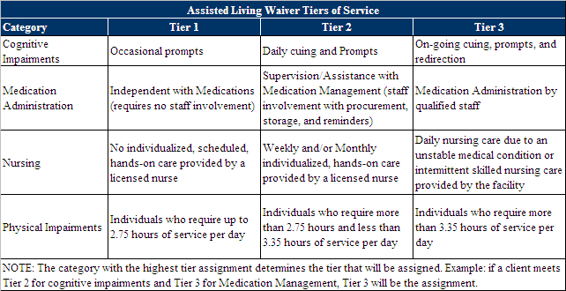
Data Source: http://aspe.hhs.gov/daltcp/reports/2007/07alcom3.htm#OH

Ohio Administrative Code (OAC) 5101:3-33-07 dictates the methodology used by ODA for Assisted Living rate setting purposes.

Current Assisted Living Program
In State Fiscal Year 2008, over 90% of the expenditures in the Assisted Living program were in Tier 3. Forty-four unique service providers delivered Tier 3 Assisted Living services. Tier 2 services were provided by 12 providers and Tier 1 services were provided by one provider. The numbers of providers billing for each tier of Assisted Living services are not mutually exclusive; that is, there are some providers that bill for both more than one tier of service. Unduplicated users of the Assisted Living Waiver program in Tier 3 represented 90% of the Waiver consumers.

Table 32: Assisted Living Service, FY 2008
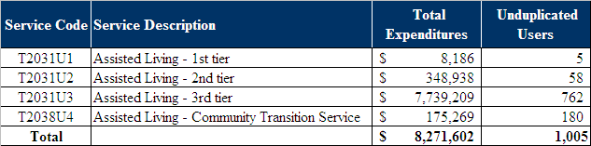

B. Strengths and Weaknesses Analysis

The following table represents a summary of the Assisted Living Waiver Program strengths and weaknesses analysis. All data is arranged according to the key measures that PCG uses to evaluate programmatic strengths and weaknesses, as detailed earlier in this report.
ASSISTED LIVING WAIVER PROGRAM
Measure | Issue Noted
Fairness | - Strength: Current rates appear to be fair as evidenced by the ability to attract an adequate supply of service providers in most areas of the state.  - Strength: The current payment structure is a tiered system based on level of care needed.  - Weakness: There are areas of Ohio where the demand for services is not being met.
Quality | - Strength: Current rates appear to support the provision of services at a level of quality that is generally acceptable.  - Weakness: The current rate setting methodology does not include quality considerations.
Efficiency | - Strength: Assisted living services provide a less expensive and more attractive alternative to nursing facility care.  - Weakness: There have been delays in being able to obtain an Assisted Living Waiver entry assessment resulting in delays in being able to receive an Assisted Living placement.
Acceptability | - Strength: Current rates are sufficient to attract an adequate supply of providers in many areas of the state.  - Weakness: Some areas of the state are experiencing difficulty in attracting enough participation in the program to meet the demand for services.
Resource Based | - Strength: The tiered rate structure is designed to account for differences in the level of care needed.  - Weakness: Since most of the people receiving services are classified in Tier 3, there is a need to adjust the tiers.  - Weakness: The tiered structure should reflect the cost of providing services to individuals who have special needs, such as those who have dementia.
Simplicity | - Strength: The current rate setting methodology is easy to understand and administer.  - Weakness: The basis for establishing the current rates is not well understood.  - Weakness: The current rate setting structure is not tied to the actual cost of delivering services.  - Weakness: Delays have been experienced in getting approval for services for individuals.
Outlier Recognition | - Weakness: Providers do not want to service high needs clients due to the current level of rate reimbursement.  - Weakness: The payment rate creates transportation service limitations which prevent individuals from being able to maintain community connections.
Compliance | - Strength: The rate setting methodology appears to meet CMS guidelines and relevant state statutory and regulatory requirements.
Other applicable comments | - Strength: The community transition fee is helpful to many individuals, especially those who are transitioning from nursing facilities.  - Weakness: The community transition fee does not always cover the staff time involved in helping individuals make the transition to Assisted Living.

The following are more detailed descriptions of some key points noted in the previous table.

Strengths of Assisted Living Waiver Program

The tiered reimbursement rate system is a good concept.
Stakeholders felt that the current rate reimbursement system based on assessing the client’s level of care to determine rate reimbursement is a good concept. Providers felt that having the AAA complete the client assessment and set the level of care tier, removes the burden of assessment off of the provider. The level of care determination speaks to the type of services that the client is eligible for and therefore, may cause discontent amongst the client’s family. The provider is not involved with the assessment process, and therefore, is not held accountable for the final service eligibility determination. Client family grievances are dealt with by the AAA.

Community transition funds are a good benefit.
Transitional funds are a great benefit and allows for an eligible client who is entering into an Assisted Living facility to purchase items that they need to live comfortably (i.e. bed and furniture).

Weaknesses of Assisted Living Waiver Program

The tiered system of rates is not adequate in its current form.
The tiered system of rates, while described above as a strength of the Assisted Living program, can also be considered a weakness. There is not a significant difference among the three tiers. The tiers need to be redefined to be meaningful.

Payment rates are too low.
The payment rates in the Assisted Living Waiver program are considered too low in some areas of Ohio. Limited provider participation has resulted in delays in obtaining a placement. Sometimes a delay results in the individual needing a nursing facility placement by the time an Assisted Living placement becomes available.

The current rates are not cost-based.
ODA does not currently require providers to submit cost reports reflecting the actual costs associated with the provision of services. As the result, it is possible that the rates set by ODA are too high, meaning providers are benefiting financially through contracting to provide a type of service, or the rates set by ODA are low, meaning providers are losing money providing this type of service because their reimbursement is lower than their costs. The latter could impact consumer access to services and provider quality if there are not enough qualified providers willing to provide the type of service.

C. Rate Setting Recommendations

PCG recommends statewide acuity-based rates.
PCG recommends that ODA update the current tiered rate structure. The goal of this update would be to provide a more realistic rate that reflects the total amount of effort, duration, and scope of each consumer’s service. Such a change may encourage Assisted Living as a serious Long Term Care option. ODA would review the activities of daily living (ADL) approach which quantifies need based on eating/nutrition, dressing/grooming, bathing/personal hygiene, mobility, bowel and bladder control, and behavior or by the number of direct care staff hours per day.

ODA should also invest resources into defining and managing care within the tiers. It is highly likely that providers gravitated towards Tier 3 in the current system because the acuity of clients, but also because of higher reimbursement rates in the current system.

ODA should also consider reviewing the appropriateness of a regional rate setting method to account for cost differences in nursing, medication administration, and/or other direct care costs. PCG identified differing approaches within the peer states reviewed. Illinois and Washington utilize a peer grouping system based on regional cost differences. New Jersey and Oregon have statewide rates. ODJFS utilizes peer groupings for the nursing facilities and MR/DD Waiver providers. Peer groupings based on regional cost differences should be considered as part of future ODA policy.

Assisted Living
Service Description | Assisted Living Services
Recommended Rate Setting Methodology | Statewide rates that reflect the total amount of effort, duration, and scope of each consumer’s service.
Method | Acuity-based/Cost-based
Additional Considerations | Analyze need for further peer groupings (regional, NF grouping, urban/rural, etc…)
Strengths and Weaknesses | Lack of clear difference between the tiered rates to accurately reflect the difference in care needs. Suggested allotting rate adjustments for clients who require special needs, such as those who have dementia. The tiered reimbursement system allows for tiered level of care based on acuity. The units of rate reimbursement need to be fully evaluated.
Compliance with CMS Audit Concerns | Yes
Peer State Methodologies | Illinois: Regional cost-based and rebased every 7 years (avg.) based on legislatively action and availability of funding.  New Jersey: Statewide tiered based on private or shared living space. Rebased every 7+ years (avg.) subject to legislative action  Oregon: Acuity-based (5 tiers)  Washington: Urban/Rural, Acuity-based, Cost (RN, Capital, etc...)

Assisted Living
Service Description | Community Transition Payment
Recommended Rate Setting Methodology | No Change
Method | Flat Rate
Additional Considerations | Analyze need for further peer groupings (regional, NF grouping, urban/rural, etc…)
Strengths and Weaknesses | The availability of community transition funds allows qualified clients to be properly set-up in an Assisted Living residence. Rates do not always cover the costs of their equipment and supplies. Stakeholders stated that the community transition fee of $1,500 does not cover the cost of staff time involved in supporting individuals in making the transition into Assisted Living Waiver program.
Compliance with CMS Audit Concerns | Yes
Peer State Methodologies | N/A

Long-Term Recommendations
PCG has discussed numerous methodologies which, because of complexity and scope, will require a long-term strategy to implement. These themes are pervasive throughout this report and should be considered as a part of a comprehensive plan. These ideas include:

- ODA can waive certain requirements of federal law and regulation for greater flexibility in their Medicaid and the State Children's Health Insurance Programs (SCHIP). If ODA pursues a 1915(b) Waiver it will allow for the state to waive Medicaid's "freedom-of-choice" requirement, which generally ensures Medicaid beneficiaries have a choice of providers. ODA could utilize the “freedom-of-choice” provision to increase competition through “preferred provider” lists. The goal would be to limit provider enrollment to only those most qualified based on quality and costs metrics. To obtain approval, the Waiver request cannot negatively affect beneficiary access to services or quality of care, and must be cost effective, meaning it will not cost federal taxpayers more than it would cost without the Waiver.

- ODA should consider unbundling the Assisted Living service rate to allow for separate billings to address higher need clients. For example, medication management and behavioral health services/dementia would be billed as a separate and distinct service. The base rate would simply pay for the availability of 24 hour on site response capability and the other basic elements of Assisted Living services. Any other service would be carved out at a separate fee.

PCG reviewed Assisted Living programs (if operating) in all 50 states and did not identify any where there was unbundling of medication management or other services from the Assisted Living per diem. However, private payors do reimburse for medication management and other services as part of separate and distinct rates. ODA could review the private pay industry to develop ideas related to unbundling of rates for “carve out” services.

- ODA should encourage the ongoing exchange of information with providers to maximize the clinical, organizational knowledge and expertise available across the state. PCG recommends that ODA consider implementing an improved data collection system that includes cost and data reporting by providers. A basic cost and data reporting system would enable ODA to effectively identify cost standards and set rates within the system;
  - Developing a web-based, electronic, centralized and uniform reporting standard across all providers;
  - Shifting to transparent cost and utilization reporting;
  - Developing technical assistance capabilities for providers regarding cost reporting; and
  - Adopting a system that can output a regular report that shows utilization, cost, and rates for clients in Assisted Living facility settings.

- ODA should consider developing a plan to implement quality-based payment methodologies into the PASSPORT and Assisted Living Facility programs in future years. Quality-based payment methodologies, otherwise known as “Pay for Performance (P4P)” have achieved increasing interest and support from providers and insurers in the U.S. health care system in recent years. ODA should review national policies on quality-based payment and move to identify and build an action plan to build P4P measures into the system.

CMS has recently implemented quality payment standards for hospitals that measure compliance and outcomes of heart attack, heart failure, infection control, pneumonia, and patient satisfaction. These measures will be used to create a P4P payment system for hospital payments for Medicare recipients. Similar payment programs are being developed by public/private payors for institutional/non-institutional service settings across the country.

The concept of paying for program outcomes is not new to Ohio Medicaid. ODJFS has implemented a P4P payment system for nursing facilities which will make a payment of up to $3 per Medicaid day. The payment methodology is based on quantifying the number of points the provider’s nursing facility is awarded based on a review of programmatic outcomes. ODA could follow similar policy and set up a quality based payment system for PASSPORT and Assisted Living Facility services, which makes mean average payments to facilities based on similar outcomes.

Acknowledgements

PCG gratefully acknowledges the individuals, organizations and state staff who provided data, comments, suggestions and guidance in conducting this study. This includes the many stakeholders who participated in the study’s focus groups including individuals receiving services, family members, advocates, and providers.

We want to extend our particular appreciation to the following:

- Michael Moore, Community Long-Term Care Division, Ohio Department of Aging, who served as contract manager;

- Roland Hornbostel, Deputy Director of Policy and Programs, Ohio Department of Aging;

- Staff at Ohio Department of Aging, the Ohio Department of Job and Family Services, and the Ohio Office of Budget and Management;

- Area Agency on Aging Directors and Passport Directors for participation in focus groups and for suggesting regional focus group invitees;

- The Council on Aging of Southwestern Ohio, the Central Ohio Area Agency on Aging, and the Area Agency on Aging – 10B for hosting regional focus groups;

- The faculty at the Scripps Gerontology Center, Miami University of Ohio;

- Larke Recchie, Ohio Association of Area Agencies on Aging;

- Fran Savard, AOPHA (The Advocate Of Not-For-Profit Services For Older Ohioans);

- Ginger Schuerger-Davison, Ohio Health Care Association;

- Jean Thompson, Ohio Assisted Living Association;

- Kathleen Anderson, Ohio Council for Home Care; and

- Jane Taylor, AARP.

Appendix A: Stakeholder Input Not Related to Rate Setting

The following sections include comments PCG heard during the stakeholder interviews that do not directly relate to the rate methodologies for the PASSPORT and Assisted Living Waivers. PCG is including these comments to assist ODA in understanding all provider thoughts on both Waiver programs.

PASSPORT Waiver Program

PASSPORT Strengths

The PASSPORT Waiver program permits consumers greater control over their health care.
PASSPORT services allow the client to remain in their own home, while allowing them to maintain control over their own lives and, if applicable, preserve the family unit. The client additionally is able to maintain a connection to their community and maintain a social atmosphere. The client is also able to maintain control over the service they need.

The PASSPORT Waiver allows for continuity of care.
PASSPORT services allow the client to preserve their continuity of care. These clients who are utilizing the PASSPORT services are often medically fragile and therefore, it is a great advantage for them to be able to continue to maintain relationships with their current medical care providers.

PASSPORT Waiver services are perceive as a good program.
Public perception of the PASSPORT program is favorable because this program is based on serving the needs of the client and seeks to provide the client with the necessary services to keep people in their homes for as long as possible.

The PASSPORT program encourages the use of local resources.
Any willing provider who meets the PASSSPORT provider criteria can become a PASSPORT provider. Such a policy encourages the viability and the sustainability of local providers. This also allows for a mix of for and non-profit service providers. The ability for the PASSPORT Waiver to use a variety of service providers increases the likelihood that clients, who reside in rural and urban areas, have access to services.

Programmatically, PASSPORT services runs well.
Providers in the Akron area strongly felt that the current program is being run effectively. They felt that the process was extremely organized and communication channels with the AAA/PAAs are good. Some other providers felt that the current management of all PASSPORT Waiver services thru the AAAs works well. Providers appreciated the timely reimbursement for services delivered, the computerization of the billing system, and the increased use of technology in regards to ability to communicate and ability to email case managers.

Case managers work effectively in this system.
Providers feel that case managers serve an important function in PASSPORT service delivery process as they are generally supportive and help their clients to remain in their homes. The case mangers work to take care of the “red tape” so that providers can focus on service delivery.

PASSPORT services are much more cost effective than nursing home facilities.
Providers generally felt that PASSPORT services are much more efficient and cost effective than admitting a client into a nursing home/residential facility. One provider stated that the average cost of PASSPORT services for a client is less than one-third the cost of the client being admitted to a long term care facility.

PASSPORT services ease the burden on long-term care facilities.
PASSPORT services reduce the strain previously placed upon long-term care facilities so that people who are placed in nursing facilities actually do need the level of care provided there. Some providers stated that clients may need minimal services that do not necessitate a NF level of care; however, they were placed in NFs because there was no other way to care for these clients. PASSPORT Waiver services are able to deliver the needed services to these clients at the appropriate level of care.

PASSPORT Weaknesses

There are cases of diminished client outcomes.
The combination of perceived low reimbursement rates and low wages paid to service providers can create high turnover rates. Such turnover rates can impact the quality of service being provided and thus impact client outcomes from the program.

PASSPORT Waiver program has some programmatic issues.
The majority of focus group participants cited inefficiencies within the current programmatic structure to administer the PASSPORT Waiver program. Many felt that the current micromanagement of the PASSPORT Waiver services reflects legislation and political agendas rather than being need-based. AAAs would benefit from having more flexibility. Stakeholders felt that there seems to be a lack of uniformity among AAAs in interpreting and enforcing PASSPORT regulations and policies. PASSPORT providers stated that they experience communication difficulties with some AAA case managers, sometimes taking one month to receive a return communication. Lastly, some PASSPORT providers have experienced issues with service payment.

Entry into the PASSPORT system is often difficult, confusing, and challenging for clients.
Participants in the focus groups stated that many clients find the application process for PASSPORT Waiver services to be difficult and confusing. Additionally, dealing with and understanding Medicare requirements add complexity to the eligibility process. Many also asserted that the eligibility requirements to qualify for the PASSPORT Waiver are extremely strict.

Accurate and timely PASSPORT assessment should occur in order to deter long waiting lists.
Stakeholders felt that the long PASSPORT services entry waiting lists are largely due to the lack of timely eligibility assessments. Some counties have addressed the issue of waiting lists for PASSPORT eligibility by implementing a pre-eligibility determination system. The pre-eligibility determination system allows for potential clients to call their local AAA to determine their PASSPORT service eligibility. This phone call accelerates the enrollment process. Additionally, providers stated that the assessments and re-assessments must be accurate to make sure that the appropriate services are received.

Education on PASSPORT services for clients and case managers should be increased. Stakeholders felt that clients and case managers need to be better educated regarding the choice of PASSPORT services available. The increase in education on PASSPORT services will foster better service utilization and will better serve the client within the goals of the PASSPORT program. Stakeholders illustrated this point by stating that clients and case managers often do not understand the utility and functions of adult day care and therefore, clients may not utilize this service. Clients may not fully understand what their options are. The case managers’ gap in the knowledge of available PASSPORT services adversely affects client care because they cannot inform the client of their PASSPORT service options.

The PASSPORT provider referral process is difficult and inconsistent.
The referral process of clients to providers is inconsistent and greatly varies. This inconsistency negatively affects PASSPORT service providers for they are often unable to anticipate future service needs. Stakeholders stated that they do not understand the current referral system. Suggestions for improvement include increasing the use of technology so that providers can log into a service referral site on a daily basis if they are seeking new clients to serve.

Hospital discharge planners need to be better informed about PASSPORT services.
Stakeholders believe that hospital discharger planners see not knowledgeable about PASSPORT services and do not see these services as a viable option to nursing facility placement. Increasing support and education from those who are responsible for hospital discharge planning will help individuals access the most appropriate services.

There is a PASSPORT provider service gap that is affecting service delivery.
Stakeholders stated that there needs to be more stable and qualified PASSPORT service providers in all service areas. Currently, there are large regional variances in the concentration of PASSPORT service providers. These regional variations result in some regions having a large number of service providers and others with very few providers. These regional variations cause service gaps that result in clients having difficulties securing needed services, thus affecting the integrity of the PASSPORT Waiver program.

A staff registry system would be helpful.
Stakeholders suggested creating a staff registry system that would include staff criminal background checks and employment history. Such a registry would allow providers to better understand the overall profile of the potential employee and to detect possible provider “jumpers” who should not be working in the field and who present a potential threat to clients. This would also help reduce staff turnover.

Clients should be held accountable for how they use services.
Providers expressed concerns about situations where scheduled services cannot be delivered due to the absence of the client or refusal by the client. Providers are not compensated for services in these situations and the provider must absorb the undelivered service costs. The most problematic service point cited related to meal delivery and personal car services. Providers felt the PASSPORT Waiver system must develop a method to establish greater client responsibility for informing providers of changes in their circumstances or wishes. Another solution is to allow partial provider reimbursement for these attempted and undelivered services.

Providers are often uninformed of client’s status in a timely manner.
Providers expressed concern over the lack of a structured client status notification system (an expansion of the aforementioned weakness). Providers often do not receive timely notification of a client’s death, admission into a hospital, or admission to a long term care facility. Lack of timely notification deters the ability for the provider to adjust their service delivery schedules or recapture equipment that they may have placed in the client’s home.

Linking clients with staff who live nearby would save money.
PASSPORT providers suggested that one way to contain costs is to develop a service delivery structure that links clients to staff who live nearby. An example of this is to secure staff that lives within close proximity of the client so that the provider can keep the service delivery costs at a minimum by spending less on gas and travel time. This will also encourage the client to continue their engagement in their immediate community.
The quality of PASSPOST services must be measured and monitored on the provider level.
Stakeholders expressed concern over the quality of services delivered by PASSPORT providers. The competitive bid process for establishing rates of reimbursement is thought to drive out some quality providers because quality indicators, such as access, quality, and consistency, are not always built into the bid process.

Stakeholders felt that clients may not receive the level of service required. There is not a consistent, statewide structure to ensure that quality indicators are reviewed during the provider assessment/certification process. Additionally, the AAAs do not have the ability to sanction PASSPORT service providers if a violation occurs.

Recommendations offered during the focus groups included implementing a quality monitoring system that also provides the applicable AAA with the authority to sanction providers. Suggested quality monitoring variables include an outcome based indicator, process monitoring variables, the number of PASSPORT clientele served, client input regarding services received, adverse incidence reports, staff turnover rates, and monitoring frequency of clients switching providers. The quality monitoring data collected can also be incorporated into a format for clients to utilize when they are choosing PASSPORT service providers. Some stakeholders felt that the current system of open provider enrollment does not provide for control over quality, wherein competitive bidding allows more control.
Assisted Living Waiver Program

Assisted Living Strengths

The program is well received and experiencing rapid growth.
Many providers and consumers are in agreement that the Assisted Living program in Ohio is growing rapidly and it is a good service to have available. The program fills a void in the continuum of care for seniors. Assisted living allows individuals to maintain their independence, dignity and privacy, while providing the comfort and services necessary to maintain a good quality of life. The Assisted Living Waiver program also allows clients to maintain community connections. Client’s families are comforted by having the Assisted Living Waiver program as an option for the family member.

The financial support available for transitioning into the Assisted Living program is positive.
The availability of the community transition fee to purchase needed furniture and furnishings is a positive offering of the program. This can be a critical element in helping individuals get back into the community from a nursing facility.

The Assisted Living Waiver program is cost effective and allows people to age in place.
Assisted living is a cost effective option when compared to nursing facility care. Assisted living is considerably less expensive and a more desirable place to live. The Waiver program also makes it possible for people who live in Assisted Living residences to remain in their homes in the event that they spend down their assets to the point where they can no longer afford to pay for services themselves. This allows people to continue to age in place and avoids unnecessary and expensive nursing facility placement.

Assisted Living Weaknesses

There are some programmatic issues affecting the performance of the Assisted Living Waiver.
Stakeholders acknowledged that the Assisted Living program is relatively new and is in a developmental stage. Stakeholders acknowledged that there are some program issues to address. Stakeholders felt that the oversight of AAAs by ODA leads to performance variability and inefficiencies within program administration.

AAA Assisted Living Waiver entry assessment delays has resulted in client waiting list. Stakeholders have expressed concerns over waiting lists that currently exist in order to get an eligibility assessment for Assisted Living Waiver services. Stakeholders stated that these waiting lists are sometimes so long that they may lead to the client being admitted into a nursing home before the AAA can complete an Assisted Living Waiver eligibility assessment. Stakeholder also stated that assessors are difficult to recruit and retain. Stakeholders suggest that AAA should be held accountable to conduct the eligibility assessment within a determined timeline.

The personal needs allowance is too low.
Stakeholders expressed concern that the client’s personal needs monthly allowance is too low and discourages peoples’ use of Assisted Living services. They felt that the expectation that the current monthly allowance will cover all costs including co-payments for medications and all personal needs is unrealistic. Stakeholders also stated that some people cannot afford to enter into the Assisted Living program because they cannot afford to pay for their medication co-payments on this personal stipend.

The community transition fee may not be adequate.
Stakeholders stated that the community transition fee of up to $1,500 does not always cover the cost of needed furniture and furnishings and staff time involved in making the necessary purchases and in supporting individuals in making the transition into the Assisted Living Waiver program. Staff is often requested to purchase furniture and other residential needs on behalf of the client. While the cost of staff time can be paid for with stipend funds, this decreases the amount available for furniture, etc. Also, people who are not transitioning from nursing facilities do not qualify for the $1500 transition allowance. Stakeholders feel that all clients entering the Assisted Living Waiver program should be have access to the community transition fee if it is needed. [However, CMS currently limits the use of this service to individuals leaving a nursing facility to establish a community residence.]

There is a need for a bed hold policy.
Unlike nursing facilities, there is no bed hold policy in the Assisted Living Waiver program. As the result, providers do not get paid if the individual is not in residence. This can create difficulties if the person wants to join their family on a vacation or if hospitalization is required. Unless the provider is willing to hold the placement without getting paid, there is no guarantee that the person will be able to return to their “home” when they wish or are able. Under current policies, families are not permitted to pay for the cost of holding the placement.

Transportation is sometimes an issue for Assisted Living clients.
Transportation limitations sometimes occur whereby a client’s needs or wishes cannot be met. Transportation is not always available to maintain community connections or to continue to see medical practioners of choice.

There are issues with the level of care determination used in the Assisted Living Waiver eligibility assessment.
Stakeholders have observed a level of discrepancy between AAA staff assessments and what the providers feel the client’s level of care is. Stakeholders feel as if the level of care assessment is a slippery slope wherein providers are often faced with borderline assessments and the issue of the client meeting eligibility requirements.

Assisted Living Waiver program discharge is a difficult process.
When it is determined that a person is no longer eligible for Assisted Living Waiver services, the discharge process can be long, difficult and expensive. During this period, the provider often must absorb the cost of services until the client moves.

Ohio Medicaid Fact Sheet: Home and Community Based Waivers, May 2007. http://jfs.ohio.gov/ohp/bcps/FactSheets/HCBS_0507.pdf
http://codes.ohio.gov/oac/5101%3A3-47
ODJFS, Bureau of Home and Community Services. “Benefits Package” http://jfs.ohio.gov/ohp/ohc/documents/BenefitPackages.pdf
OAC 5101:3-12-05, http://codes.ohio.gov/oac/5101%3A3-12-01
OAC 5101:3-12
OMDRR, “The Level One Waiver Handbook” March 2008 (http://odmrdd.state.oh.us/medicaid/docs/l1-waiverhandbook.pdf)
OMDRR, “The Individual Options Waiver Handbook” June 2007 http://odmrdd.state.oh.us/medicaid/docs/iowaiverhandbook.pdf
The ODDP, A Handbook for Individuals and Families http://odmrdd.state.oh.us/mrddlibrary/publications/oddphandbook.pdf
http://codes.ohio.gov/oac/5123%3A2-9-06
5123:2-9-06 B.16.c http://codes.ohio.gov/oac/5123%3A2-9-06
See retrieved on 9-19-08 http://www.oage.org/docs/Locally_Funded_Services_for_Seniors06.pdf
AARP Public Policy Institute (2008). State Long Term Care Reform in Indiana. http://assets.aarp.org/rgcenter/il/2008_10_ltc_in.pdf
AARP Public Policy Institute (2008). State Long Term Care Reform in West Virginia. http://assets.aarp.org/rgcenter/il/2008_10_ltc_wv.pdf
For Ohio’s Assisted Living Medicaid Waiver there is only one service. However, there are several tasks within that service which are indentified in this table. It is important to understand there is not a separated tier for each service but rather 3 tiers for the entire Assisted Living Waiver program.
O’Keeffe, J. (2007). Residential Care and Assisted Living Compendium. US Department of Health and Human Services.
O’Keeffe, J. (2007). Residential Care and Assisted Living Compendium. US Department of Health and Human Services.
O’Keeffe, J. (1999). People with Dementia: Can they meet Medicaid Level of Care Criteria for Admission to Nursing Homes and Home and Community-Based Waiver Programs? AARP Public Policy Institute
O’Keeffe, J. (2007). Residential Care and Assisted Living Compendium. US Department of Health and Human Services.
Spreadsheet entitled “Service Totals by PAA and providers with county SFY 06 07 08” received from Deb Preston, August 29, 2008.
OAC 5101:3-31-07 PASSPORT HCBS Waiver rate setting, lists the services the unit rate applies to. These are: Adult day services transportation, Home delivered meal services, Homemaker services, Social work counseling, Nutritional consultation, Personal care services, Independent living assistance services, and Emergency response system services.
Center for Medicare and Medicaid Services (2008, January 11), Final Report: Pre -Admission Screening System Providing Resources and Options Today, Region V, Department of Health and Human Services, Baltimore, MD. P. 27. The original issue arose in the Center for Medicare and Medicare Services, (2003, January) Report on Review of the State Financial Accountability of the PASSPORT 1915(c) Waiver (OH 0198.90/R1) Chicago Regional Office, Chicago, IL. See Part II pp. 3-4.
In the discussion of service codes, the word “costs” will usually refer to the amount the state will reimburse the provider for providing the service thus these are costs to the state.
The Social Security Act at section 1902(a)(30)(A). Retrieved on 9-2-08 from http://www.ssa.gov/OP_Home/ssact/title19/1902.htm . For a discussion of 1902(a)(30)(A) see http://www.nls.org/conf2003/sept2000-article.htm
The average daily cost was $30 in 1992 and $31 in 2001. See Mehdizadeh, S. and Applebaum, R.(2003, May), A Ten-Year Retrospective Look At Ohio’s Long-Term Care System, Scripps Gerontology Center, Miami University, Oxford, OH. p. 7
Straker, J. et. al. (2007, May 31), Providing Quality Home and Community-Based Services Through PASSPORT, Scripps Gerontology Center, Miami University, Oxford, OH.
The 2007 Scripps report discusses these issues at length. (Straker, 2007).
OAC173-39-02.14
Administration on Aging Retrieved on 8-29-08 from http://www.aoa.gov/prof/agingnet/NAPIS/SPR/2006/Profiles/OH.pdf
There are also home delivered meals services provided in the Home Care and Individual Options waivers, however, PCG has not collected data on their reimbursement rates.
Department of Aging, (2006), Nutrition Services 2006: A Report on Current Trends and Practices, Older Americans Act Programs Division, Columbus, OH. Retrieved on 8-30-08 from http://www.goldenbuckeye.com/infocenter/publications/nutsvcs2006.html
See Bureau of Labor Statistics http://www.bls.gov/ro5/cpicle.htm
The figure is calculated by taking the Bureau of Labor Statistics (BLS) data available as of August 29, 2008. BLS data are continuously updated and monthly data will change. Retrieved on August 29, 2008 from http://www.bls.gov/news.release/ppi.nr0.htm
OAC 173-39-02.6
Focus on Healthy Aging, (2007) Retrieved on August 31, 2008 from http://findarticles.com/p/articles/mi_m0ZRQ/is_/ai_n21107811?tag=artBody;col1 This publication documents monthly rates by provider. Other commentators quote ranges without documenting the source of the range, e.g. $10 to $30, as per for example, http://www.quackwatch.org/04ConsumerEducation/pers.html
Moore, T., (2006, October 27), Compendium of Home Modification and Assistive Technology Policy and Practice Across the States Volume I: Final Report, A Report Prepared by Abt Associates for U.S. Department of Health and Human Services (HHS), Office of Disability, Aging and Long-Term Care Policy (DALTCP) Washington, D.C. Retrieved on August 31, 2008 from http://aspe.hhs.gov/daltcp/reports/2006/HM-ATI.htm
These are all rates from the period 2003 through 2008.
OAC 173-39-02.7

